Some important services of AWS

EC2 – clastic compute cloud service this will give you bare servers

VPC- virtual private cloud let you create network in the cloud then run your server in them

S3- storage service

RDS – Relation DB service oracle and othes my sql

ELB – Elastic load balancing for load balancing

Autoscaling- for scale up s

KMS- key management system for encrypted data

# INTRO AND IAM

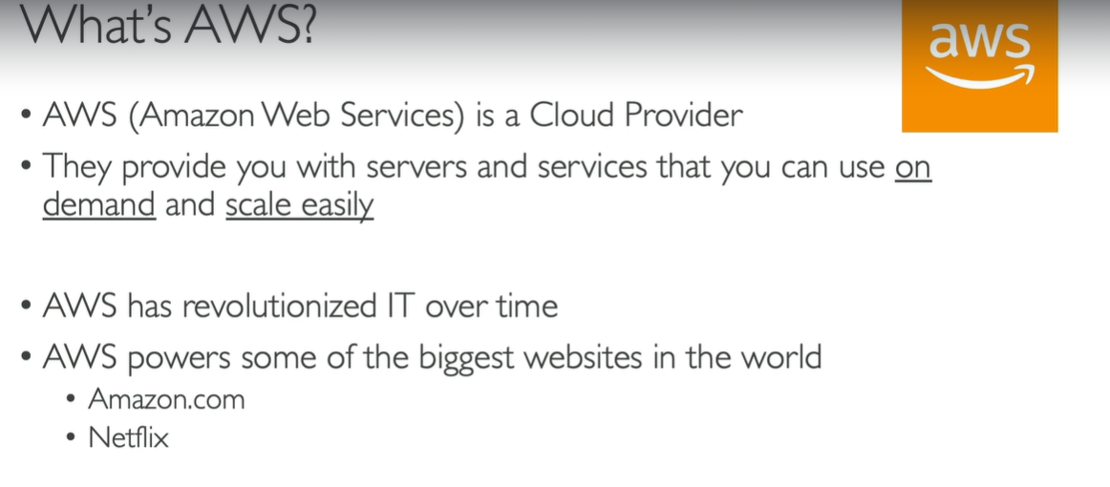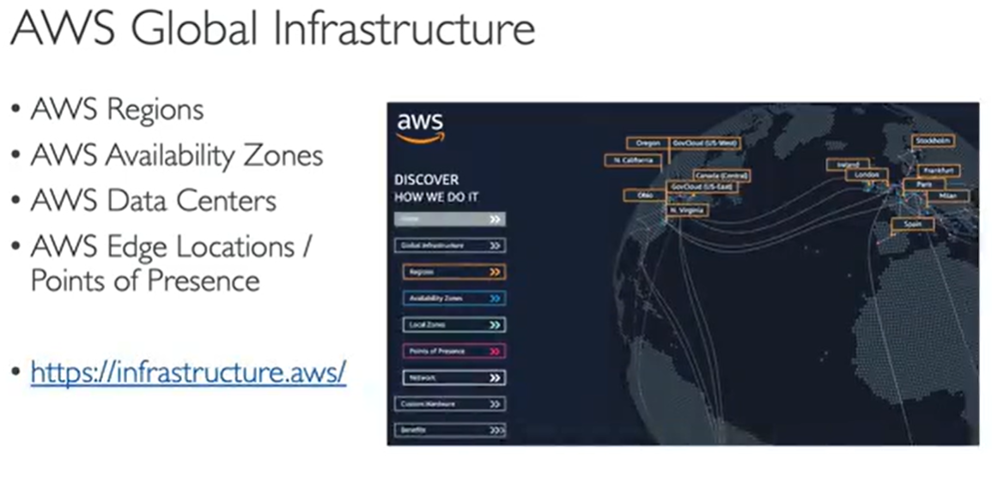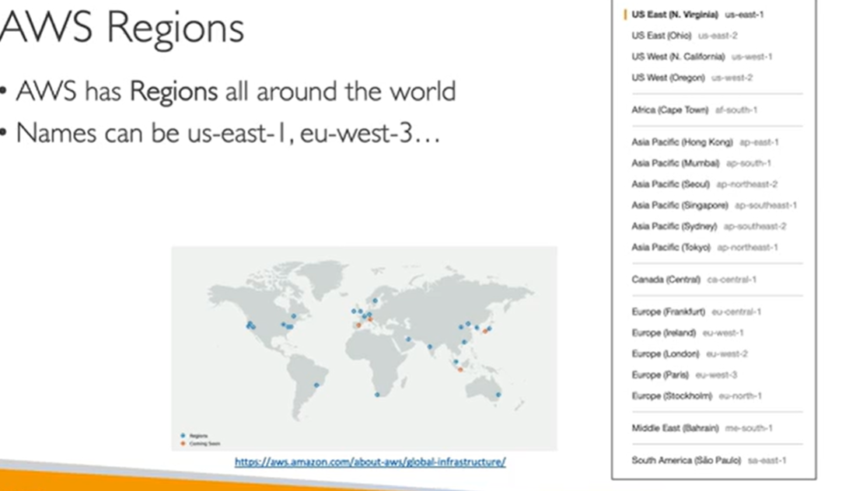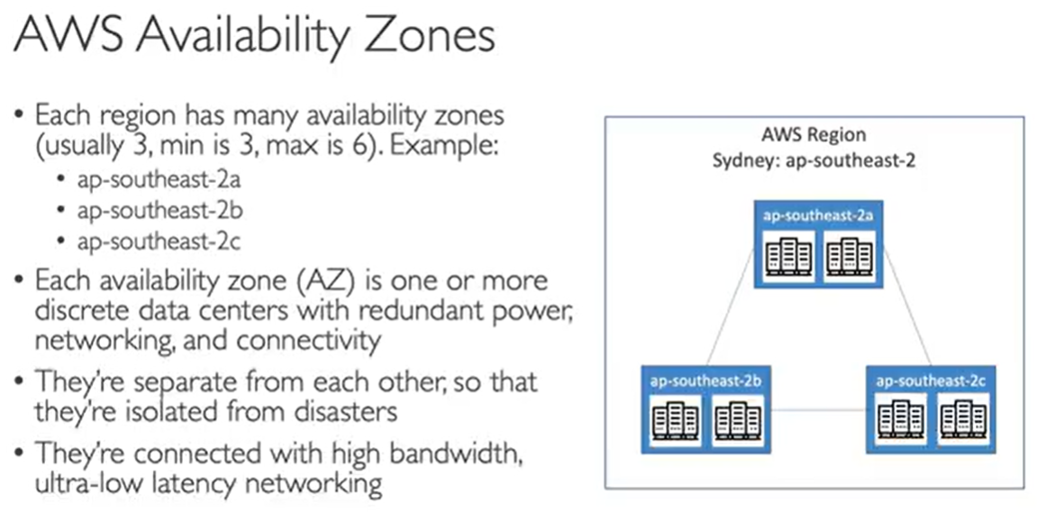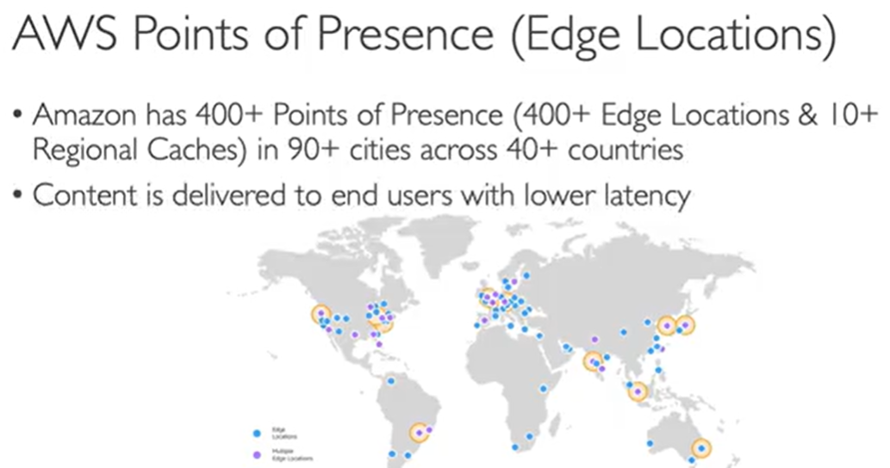

## IAM Service (identity and access management Global service)

These Access is for users and Roles below will create for services like EC2 and all

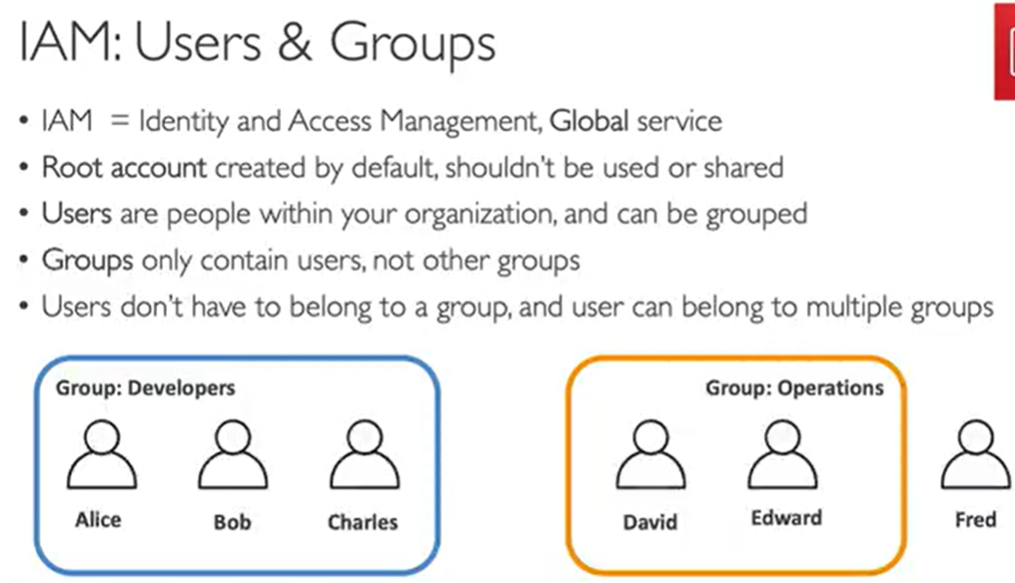

## IAM Polices (permissions -for users and groups)

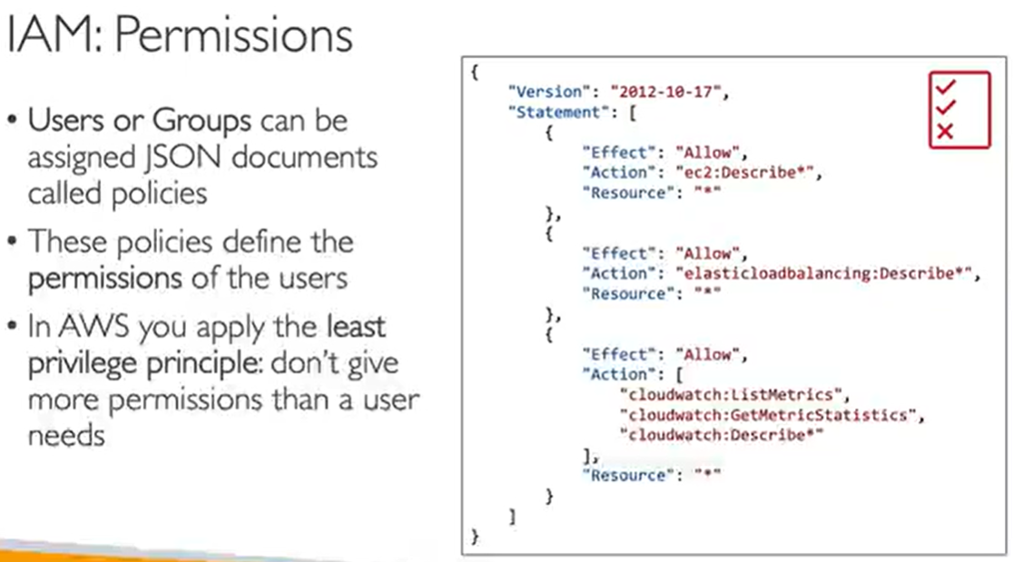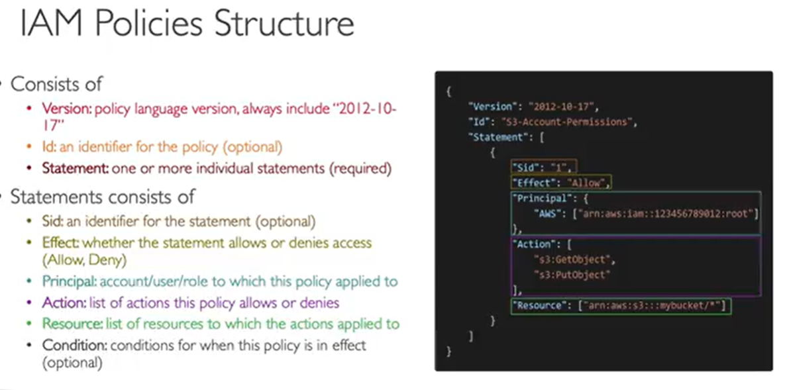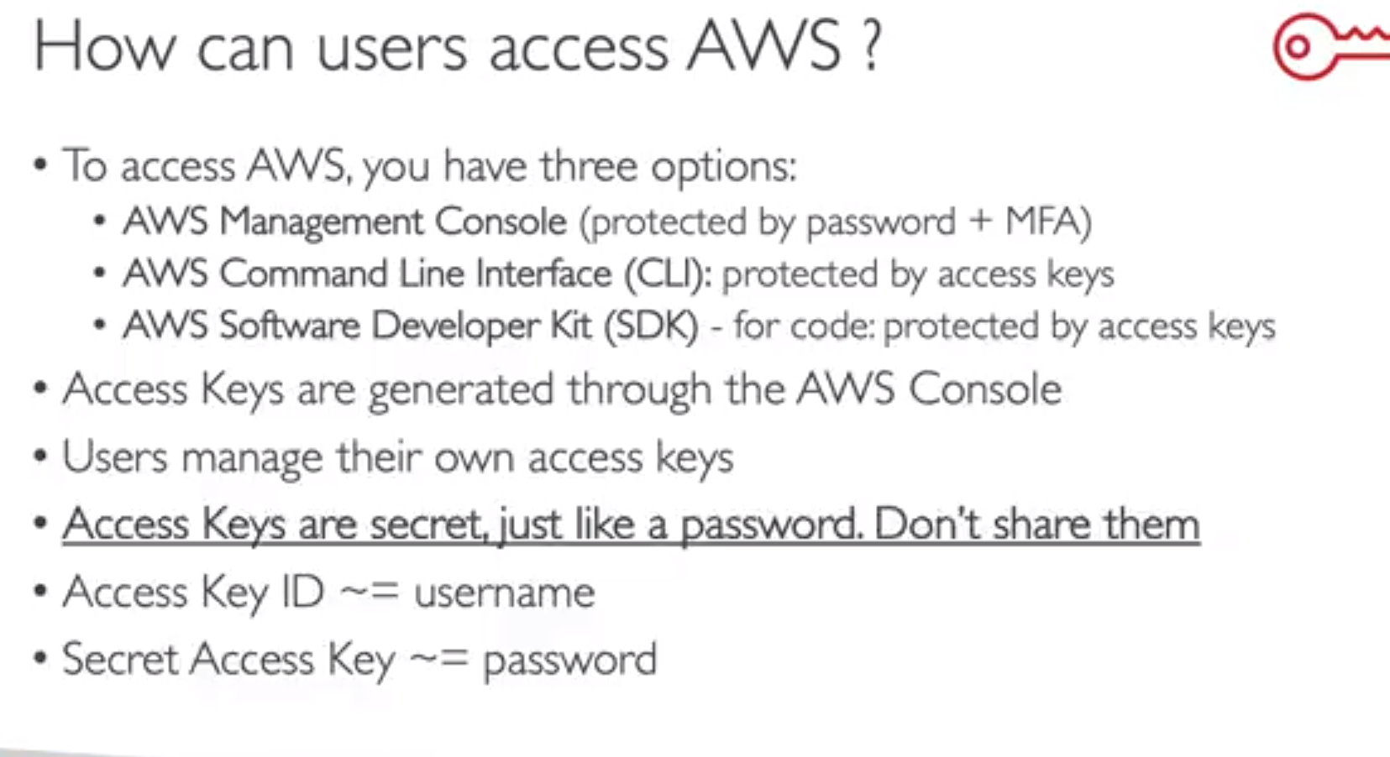

To authenticate CLI we need to set access key and secret

*~aws configure*

*~aws iam list-users (list all users in an account)*

*~aws sts get-caller-identity*

*~aws configure list*

AWS cloud shell :- to access aws account there is a button (not available in all regions)

## 3)IAM Roles – FOR SERVICES

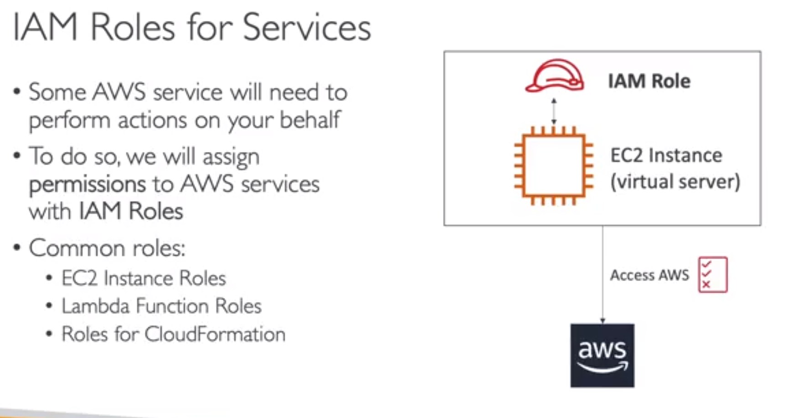

For example if EC2 instance want to perform some operation on aws we need to assign

Roles to EC2 to use our account aws.so role will give permissions to Ec2

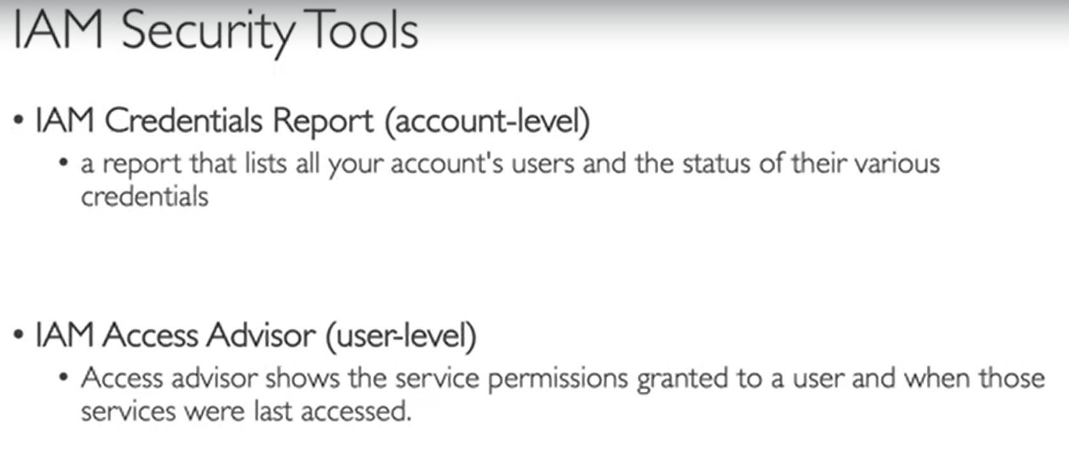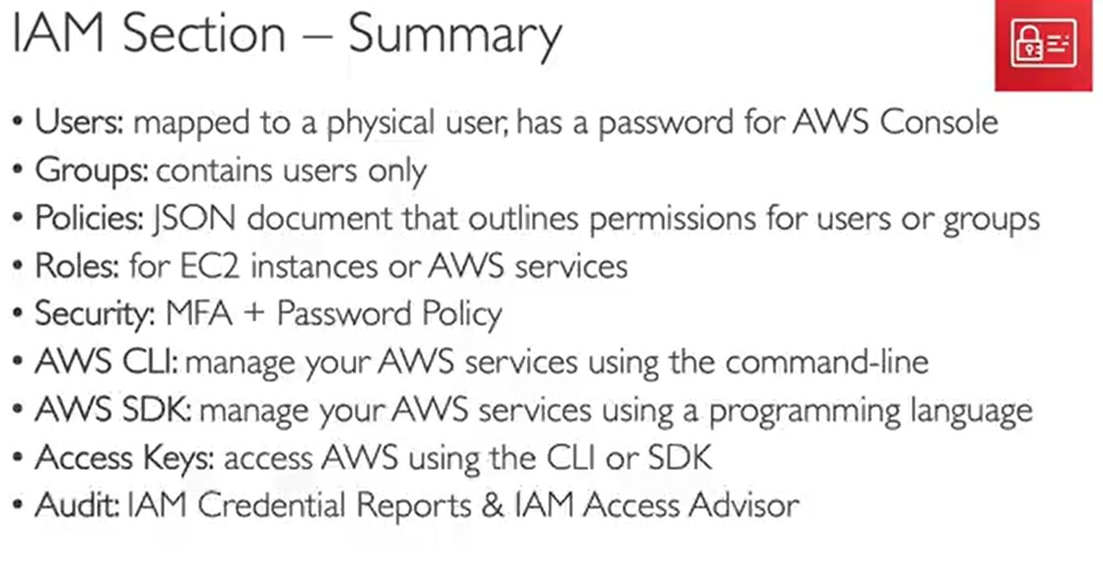

# EC2

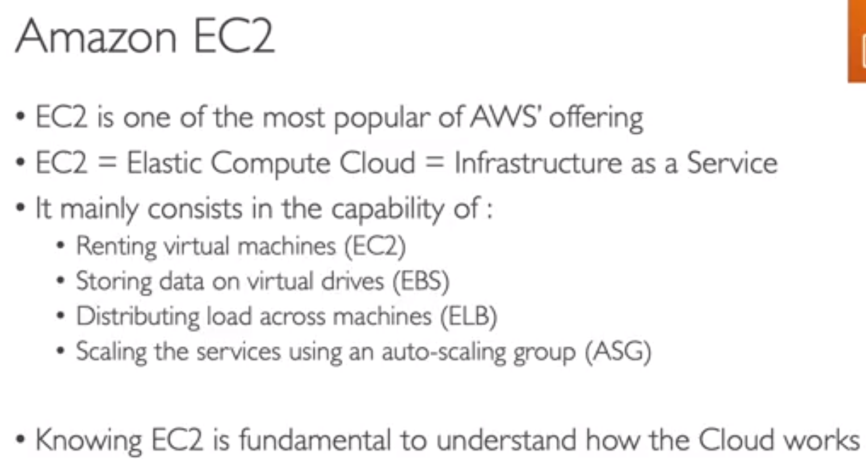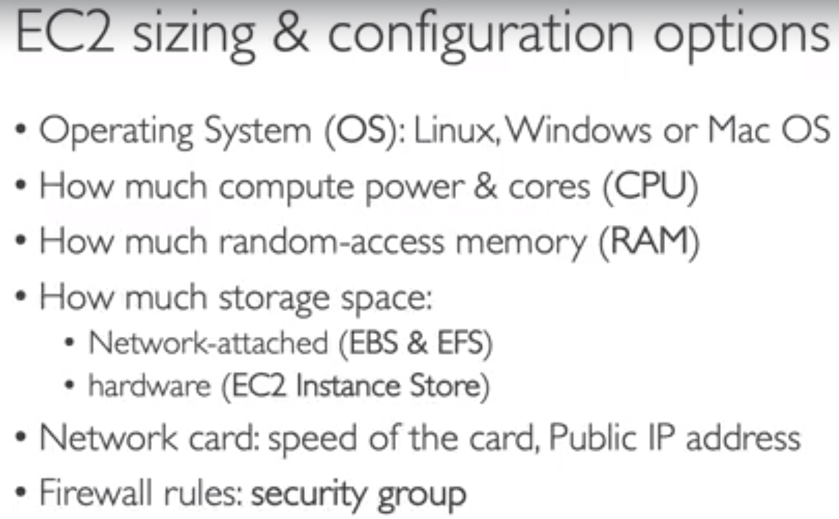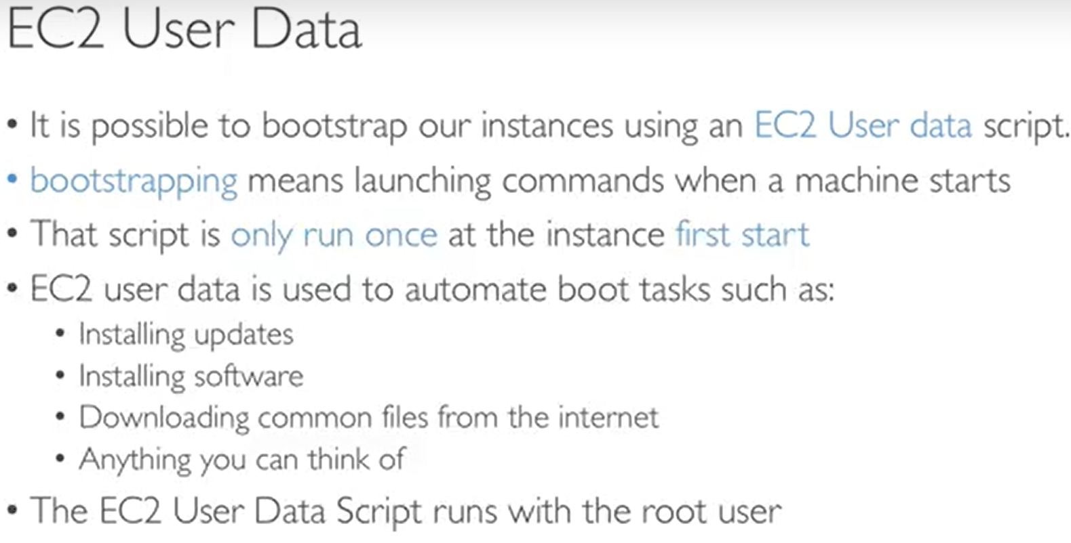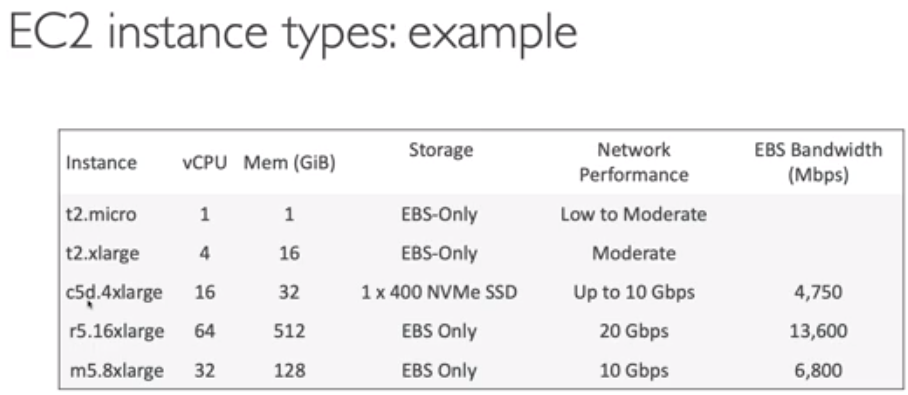

## Fire walls arround EC2 instances :-

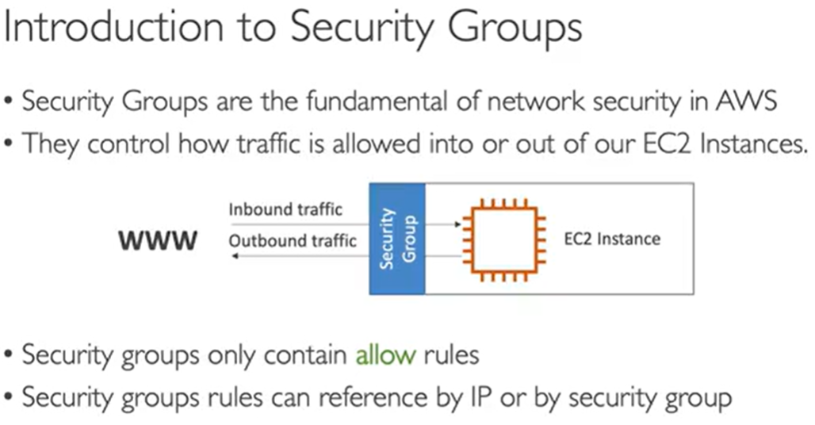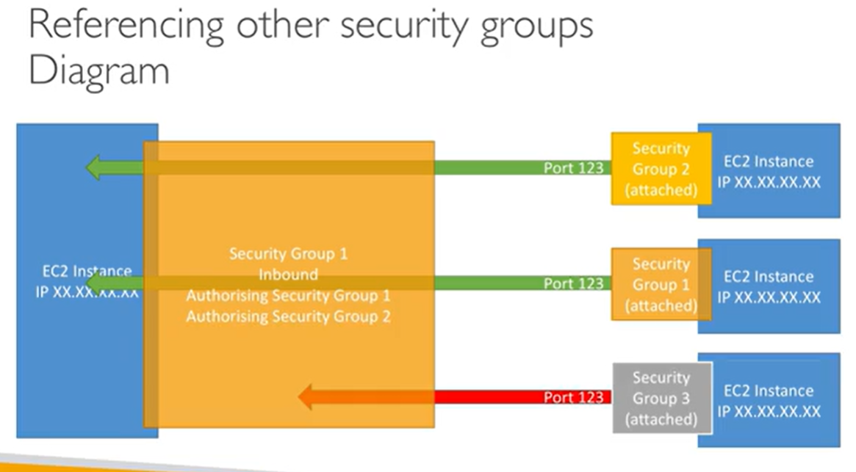

## Security Groups

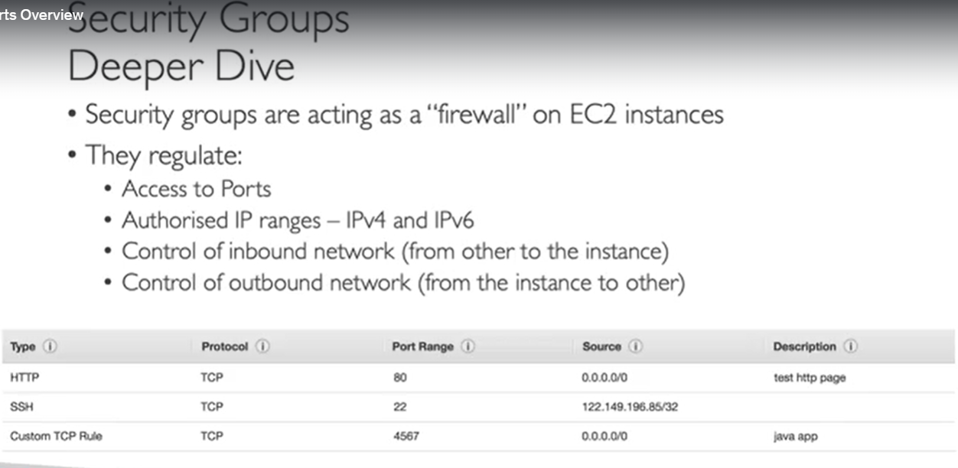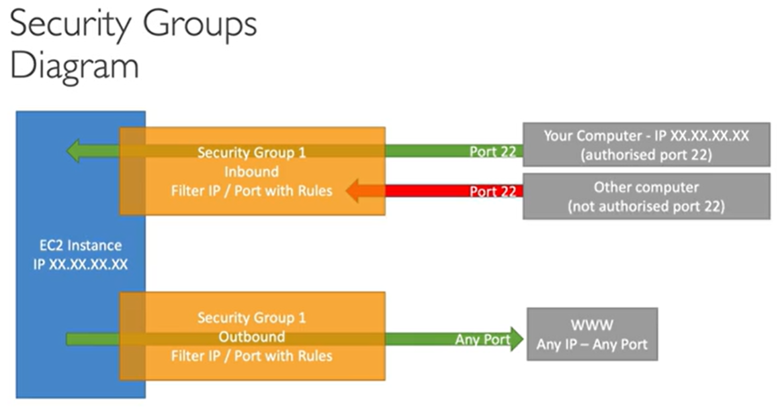

Here in Fileter IP we are allowing one Ip and blocking other in inbound rule

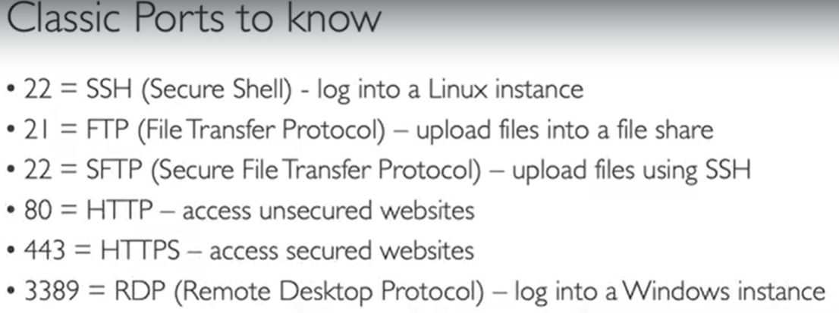

If there is timeout in browser 100% chance there is some issue with security group

EC2 instance connect :-to connect to ec2 from browser

Never add your sectret key in ec2 instance with aws configure instead attach iam roles to

Your ec2 instance and use that

Summary:- we need inbound and outbound rules to allow traffic in and out from SG.

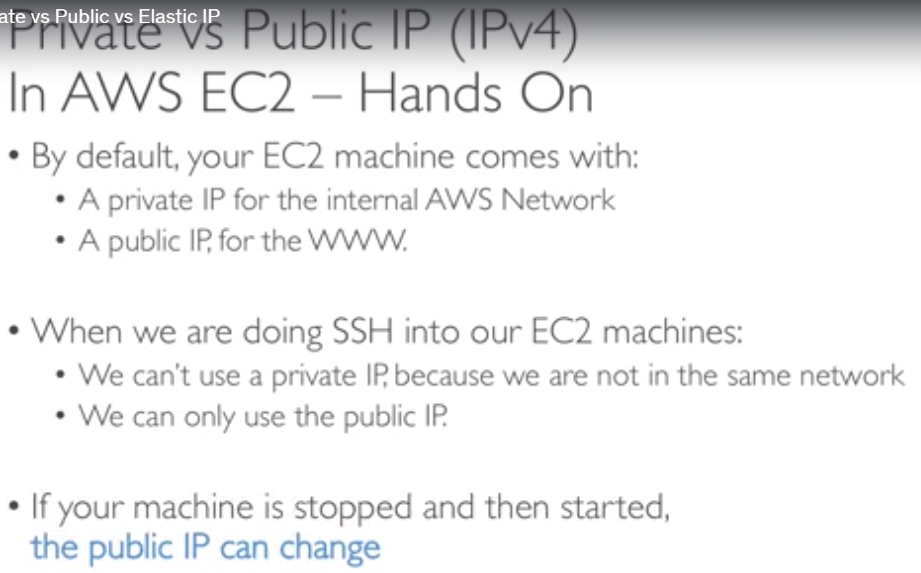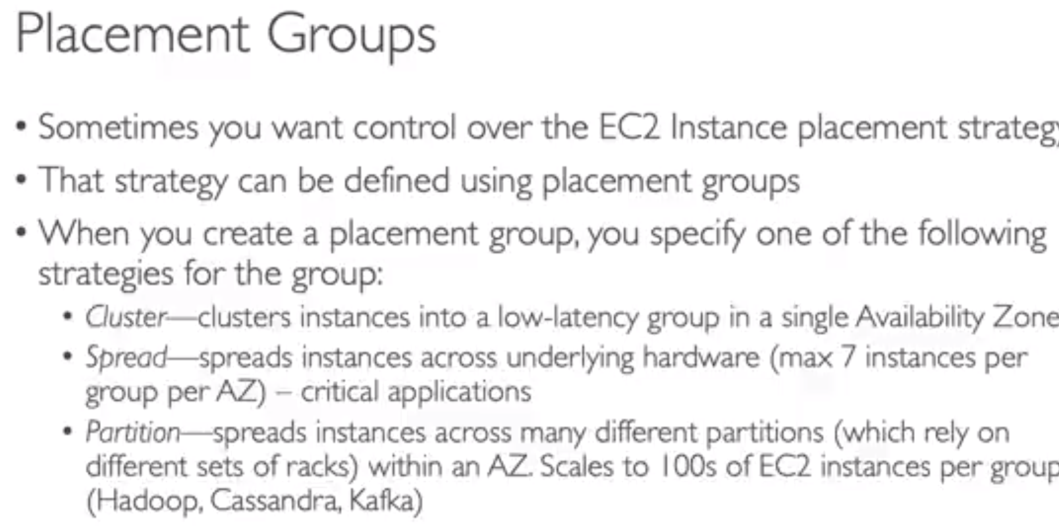

Elestic Network Interface (ENI):-

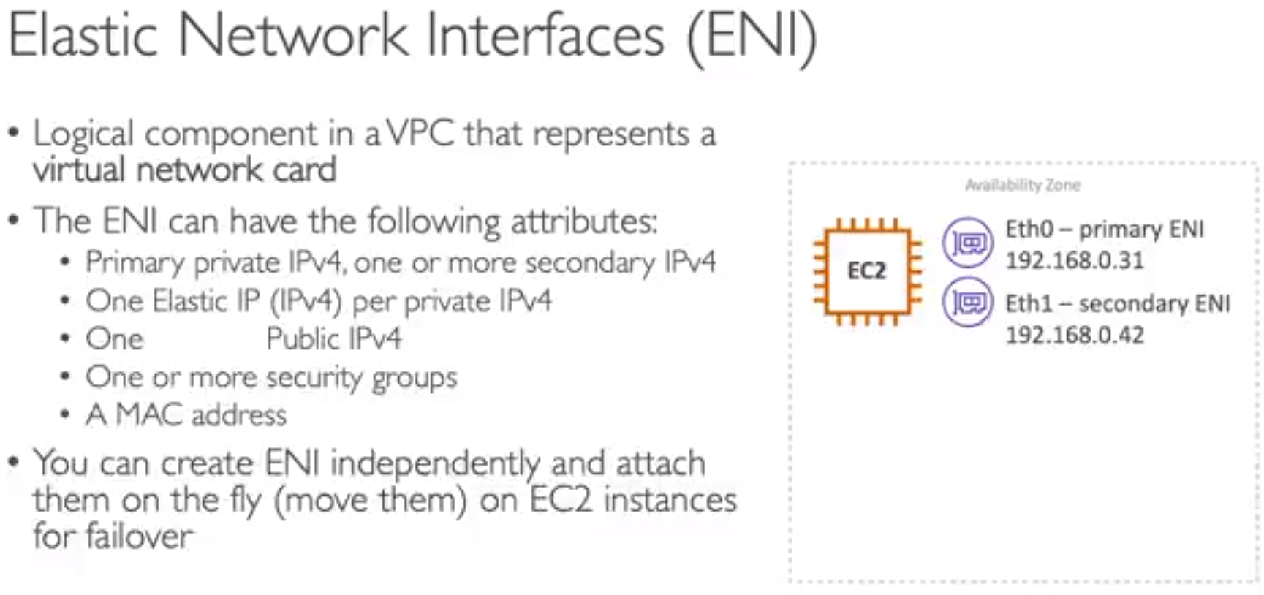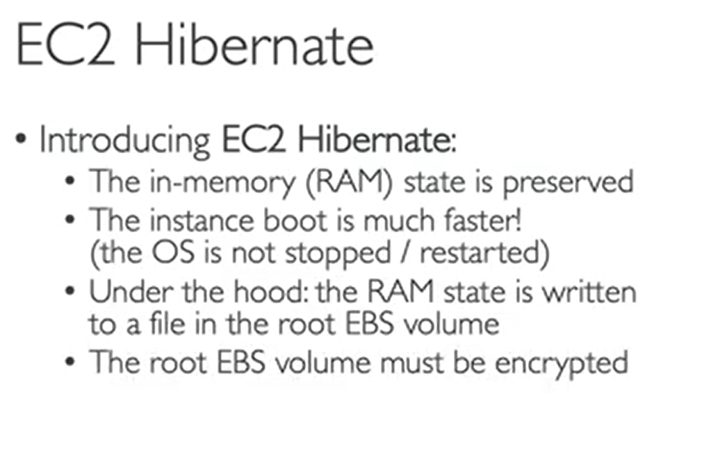

# EC2 Internal storage EBS

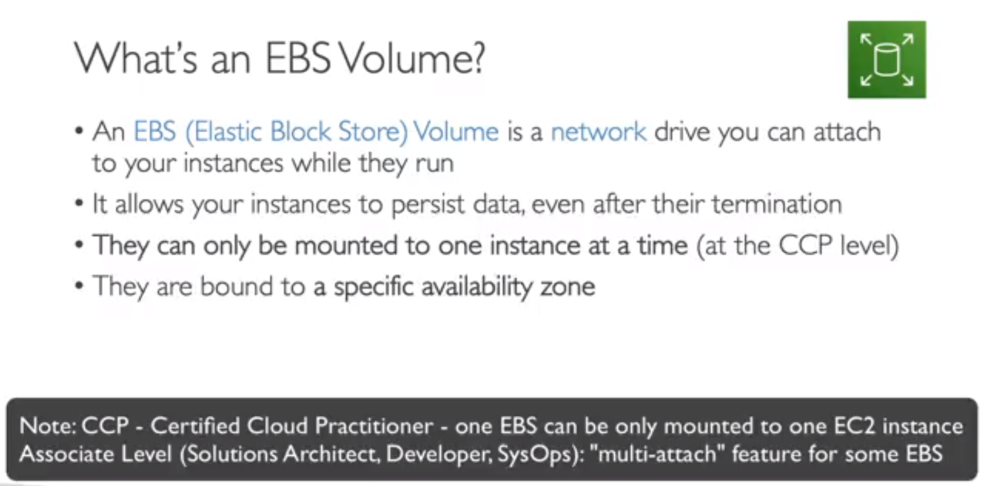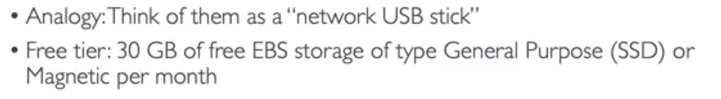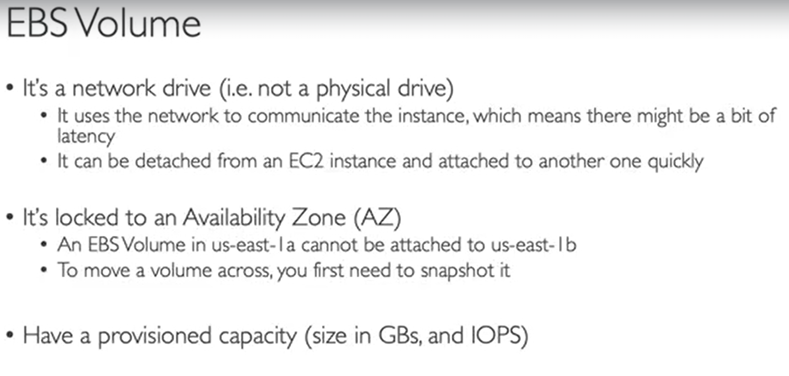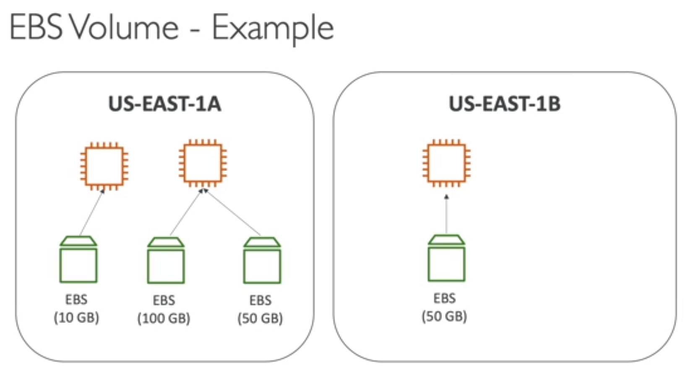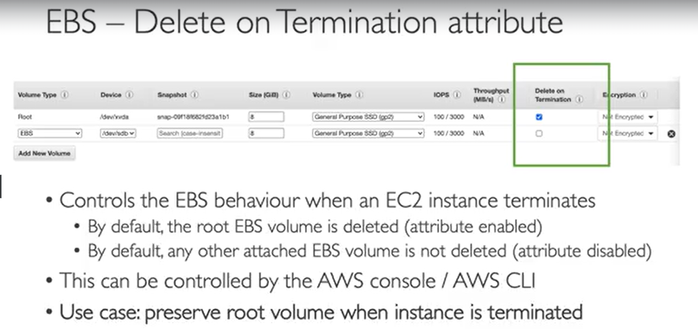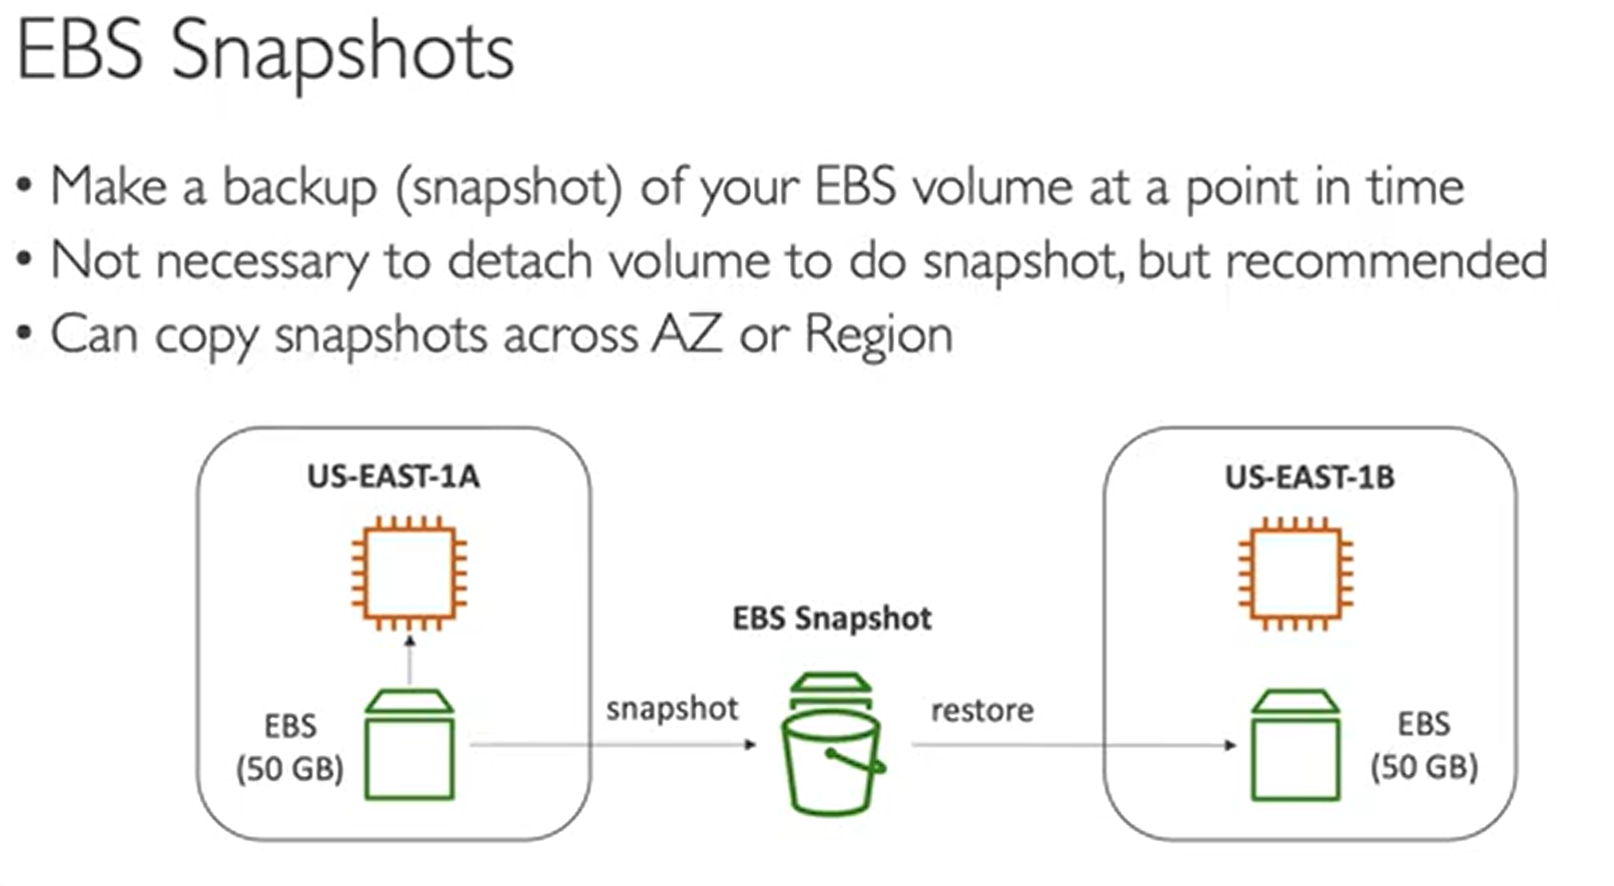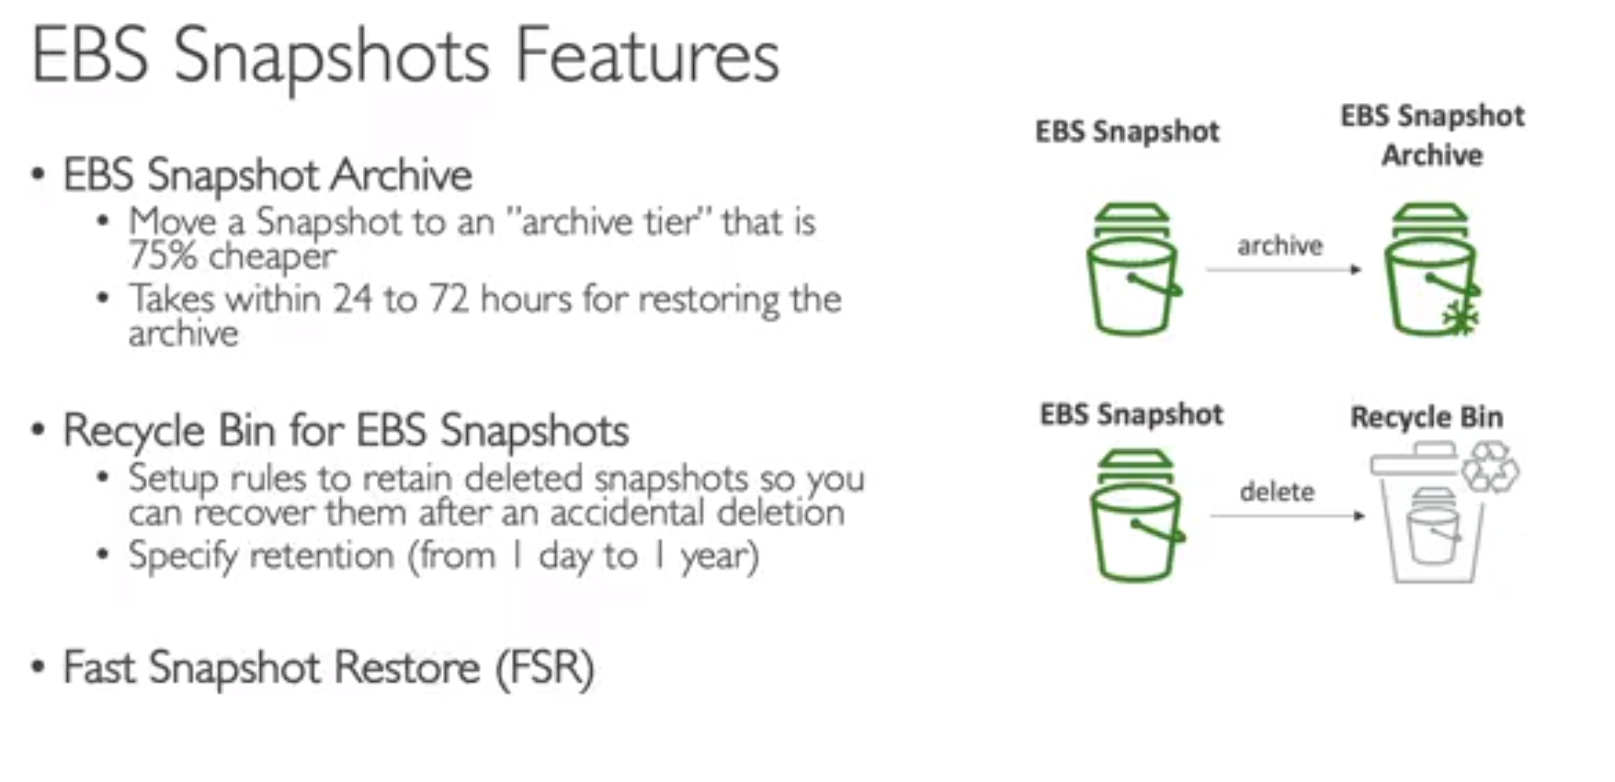

# AMI OVERVIEW

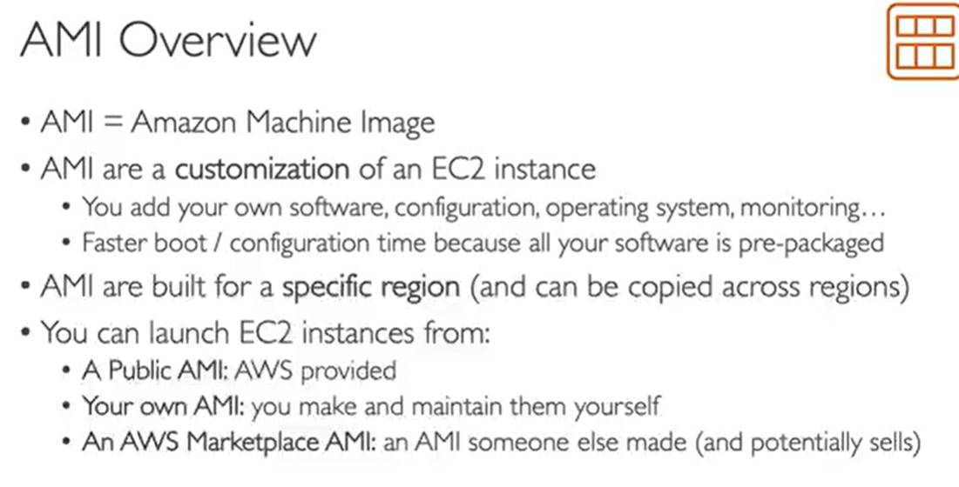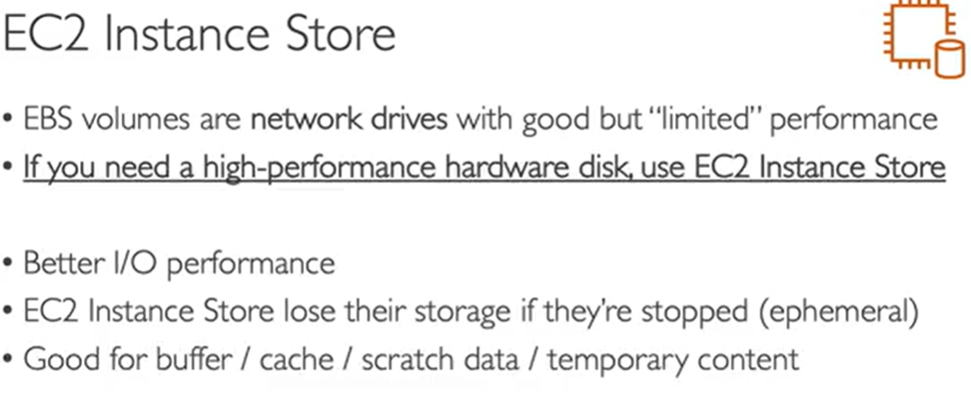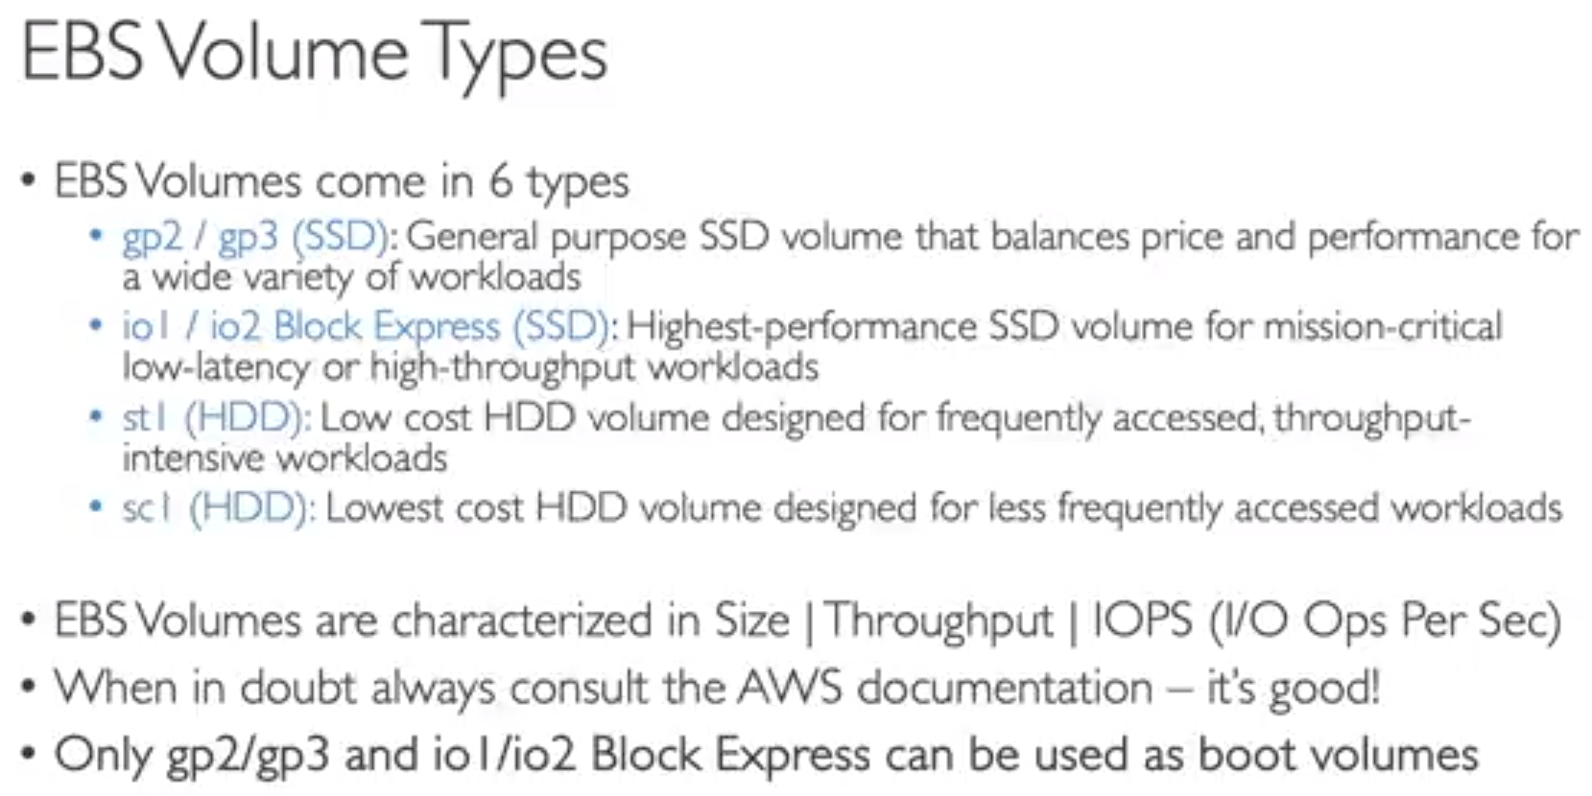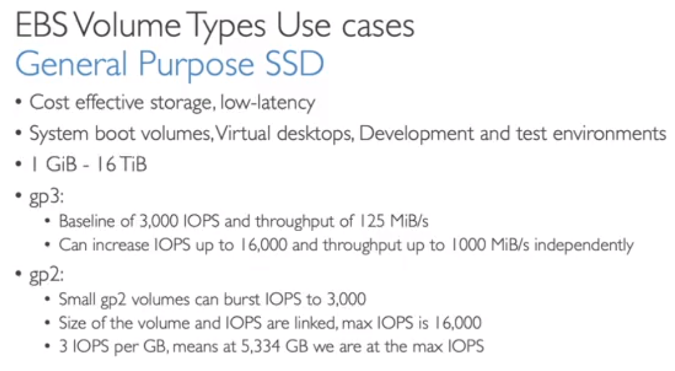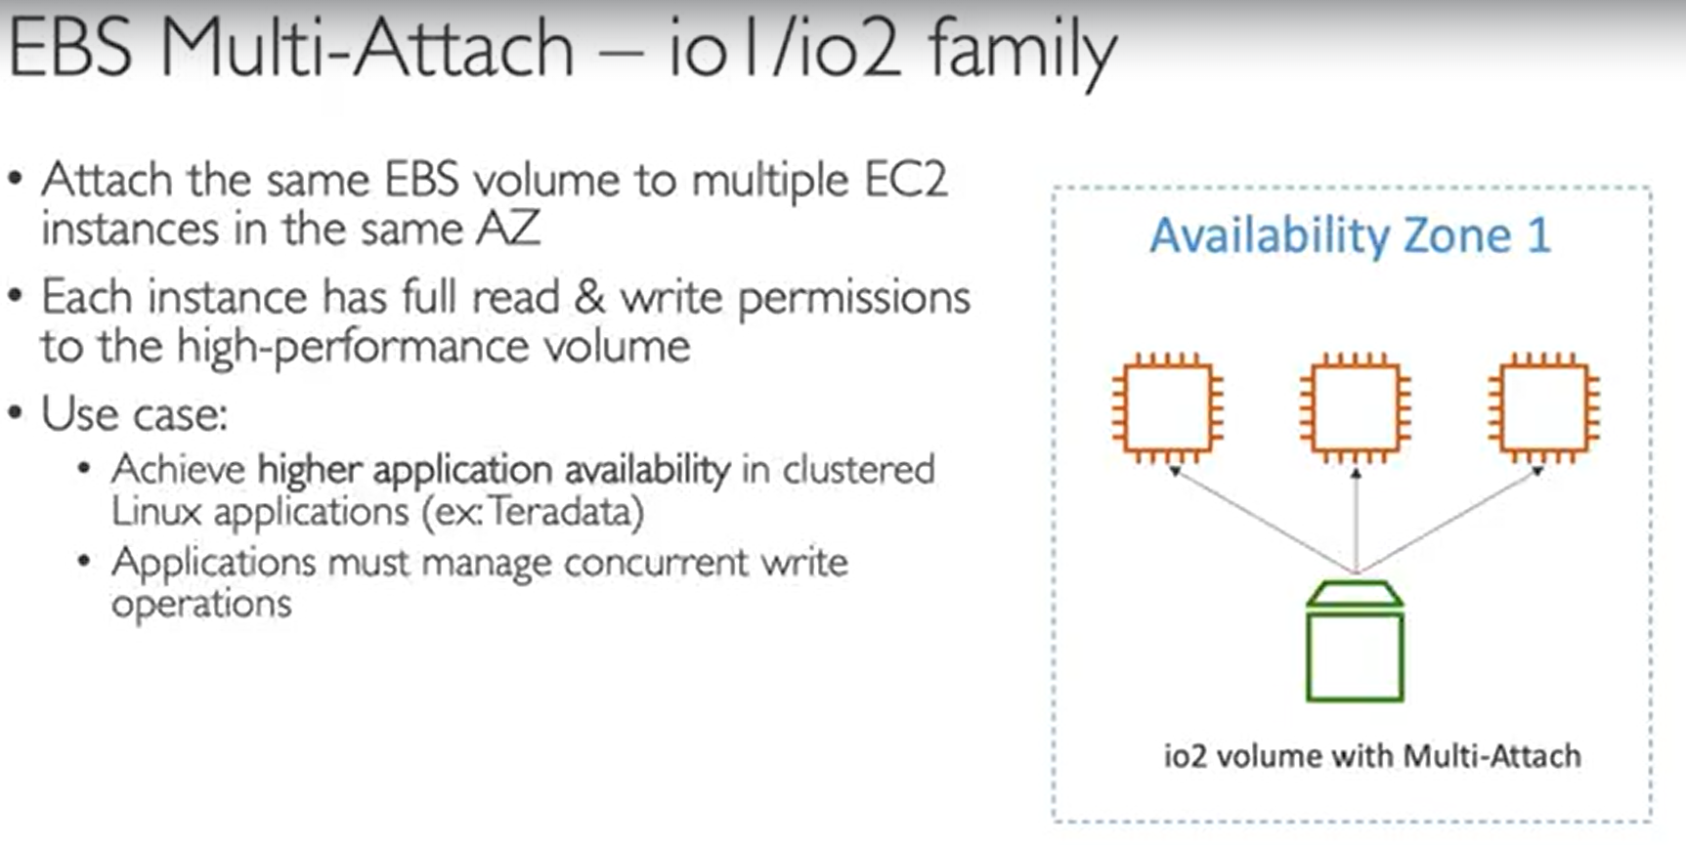

# EFS

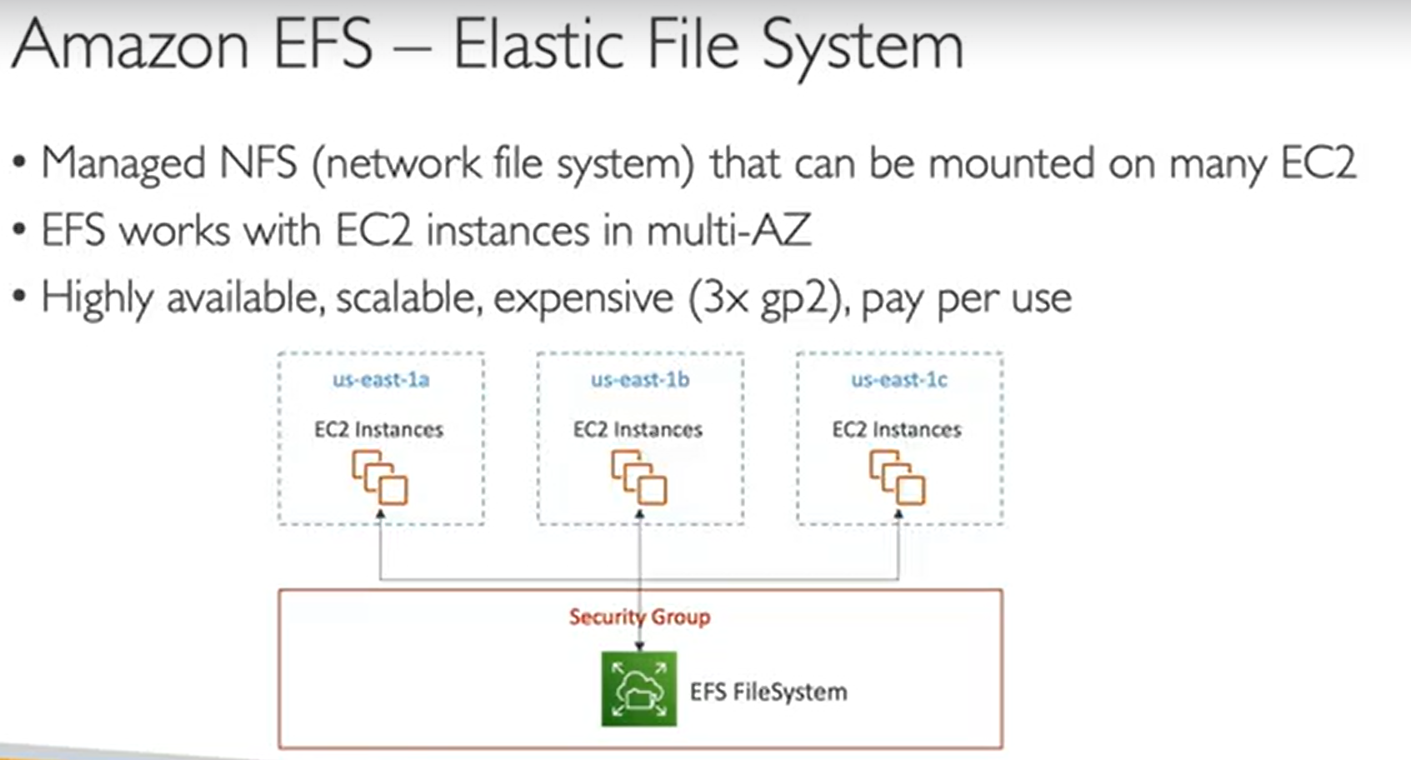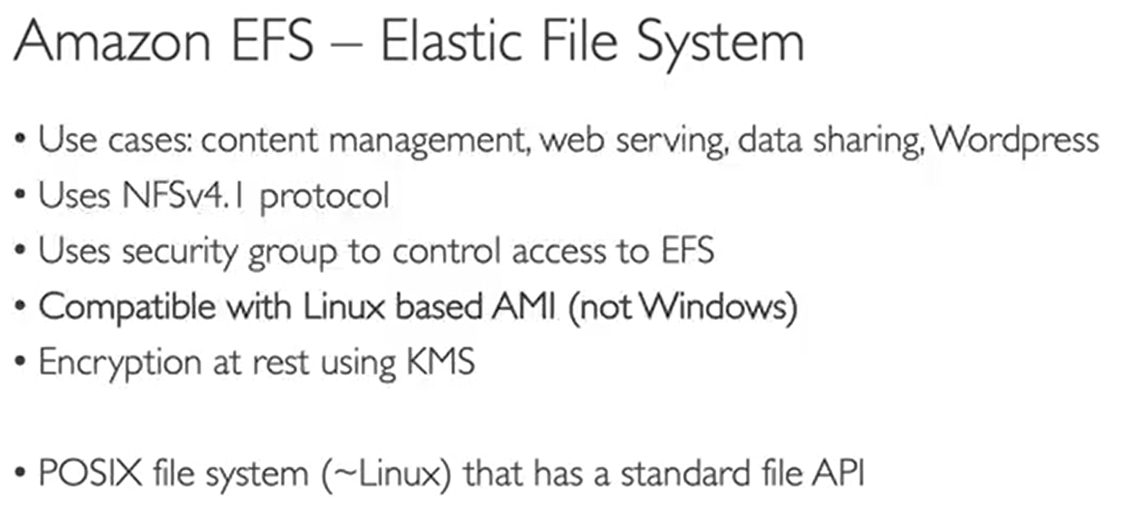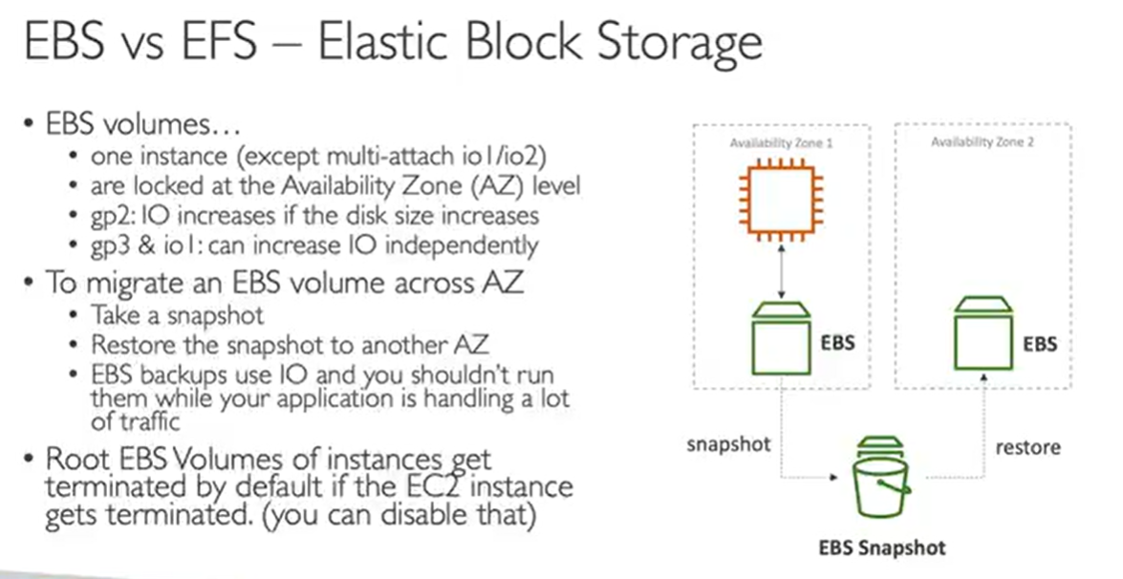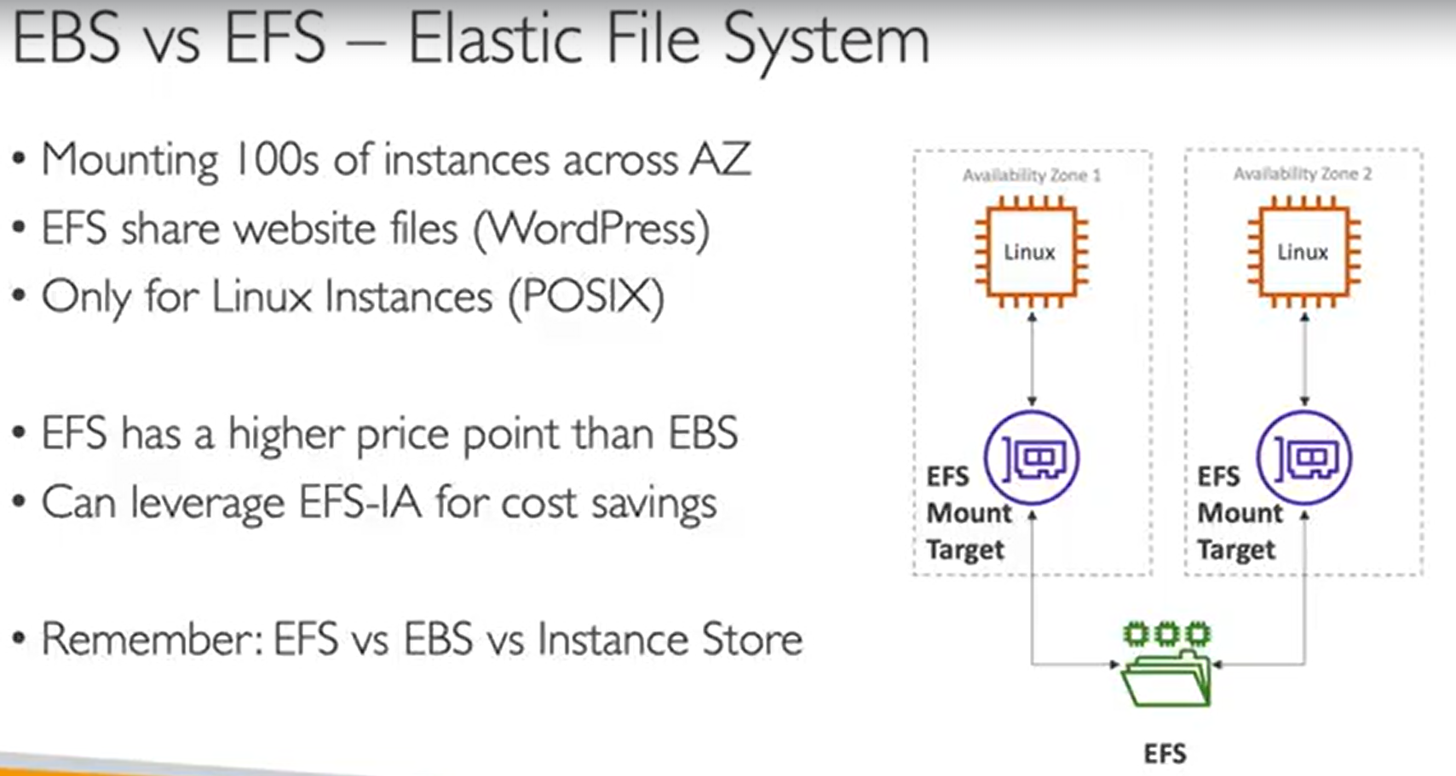

# High Availability and scalability ELB & ASG

Veritcal scalability:- increase size of instance

Horizontal :- increase no. of instance

High Availability:- Having in multiple AZs

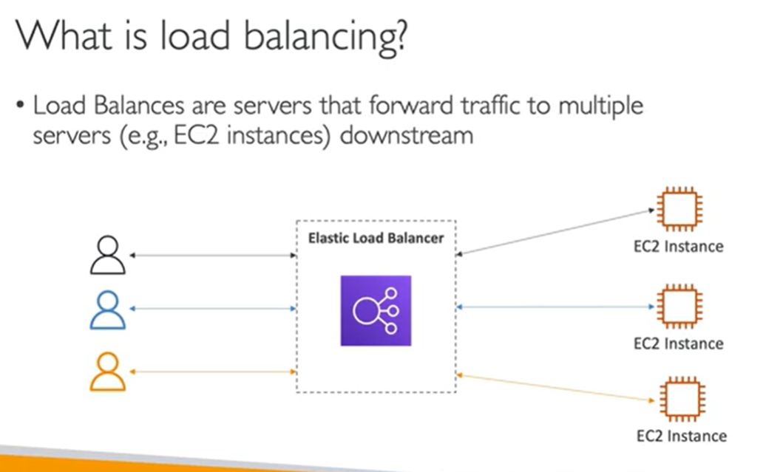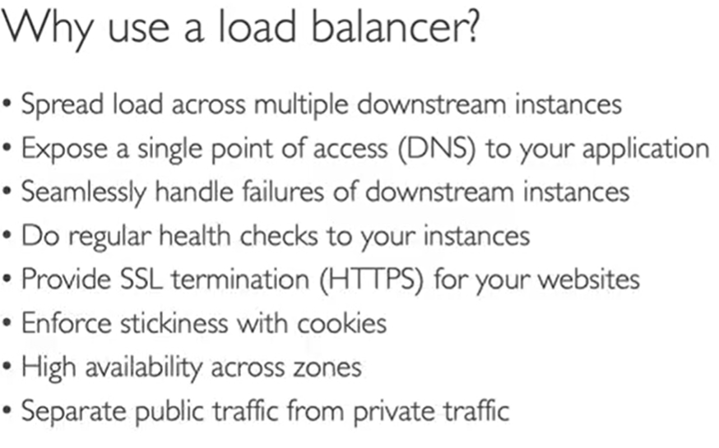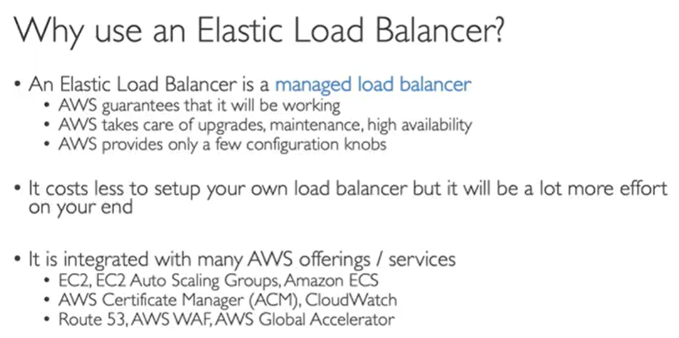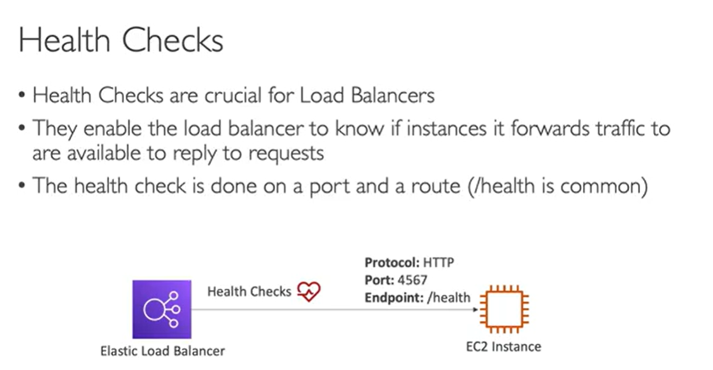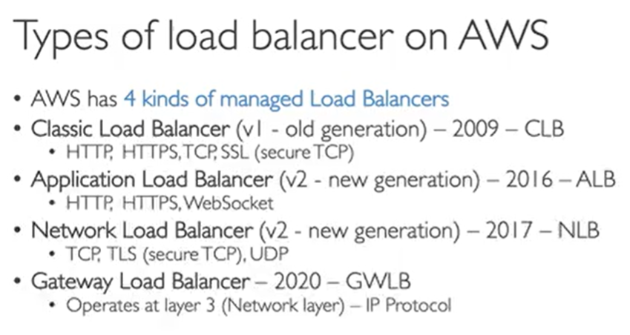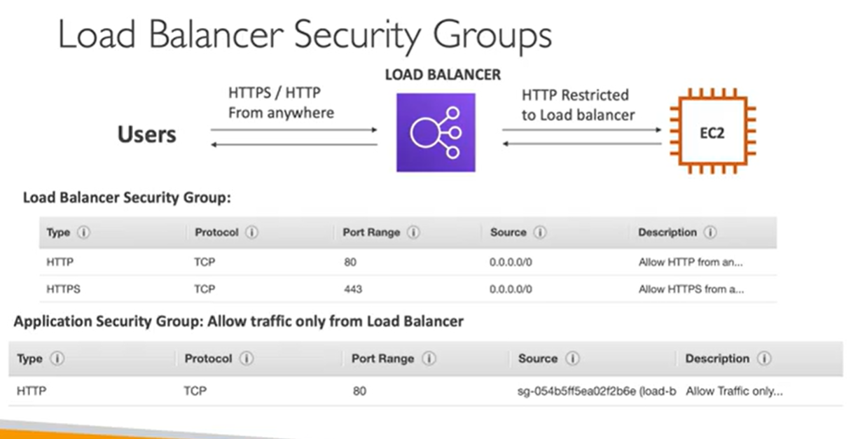

*Here we are allowing traffic on EC2 instance from load balancer only so security group(of Ec2) will be different It will have TCP and in case of source it will contain security group of load balancer (instead of IP)So we have linked both security groups of load balancer and EC2 .*

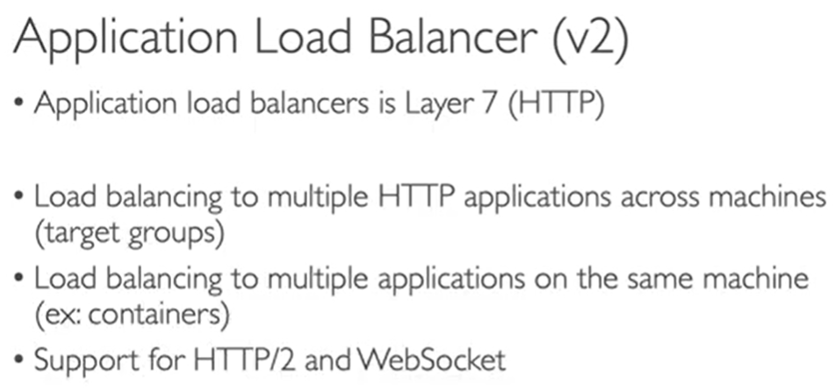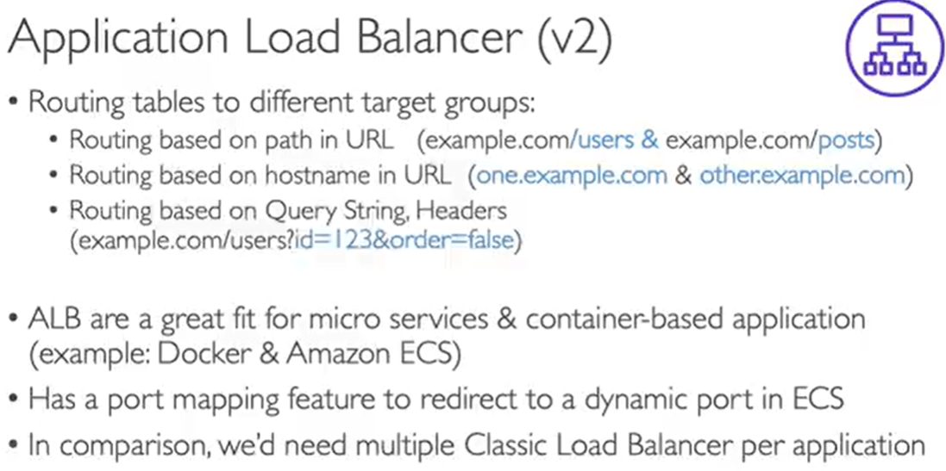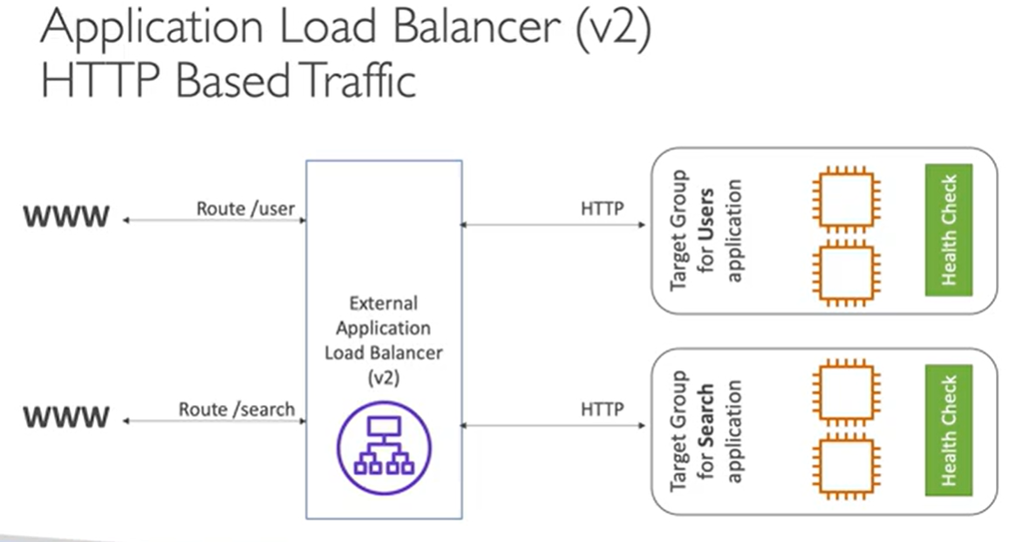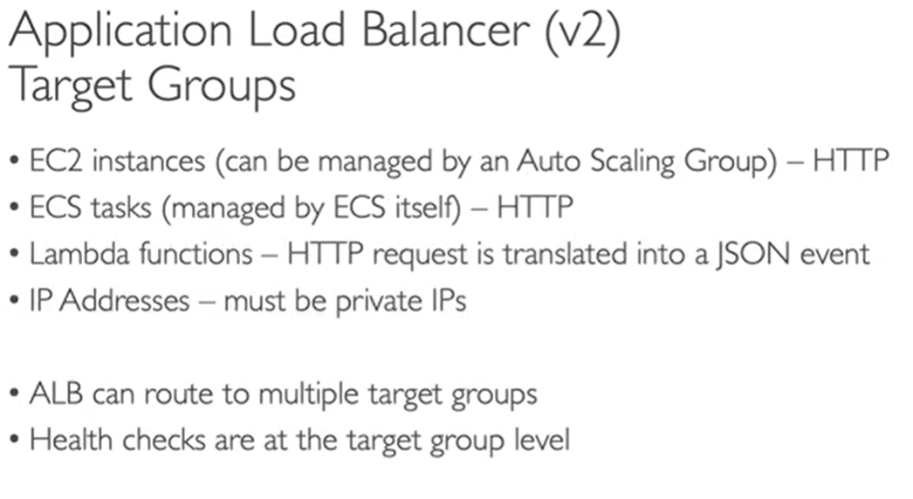

Target Groups are group of Ec2 instance where you want to route traffic ,

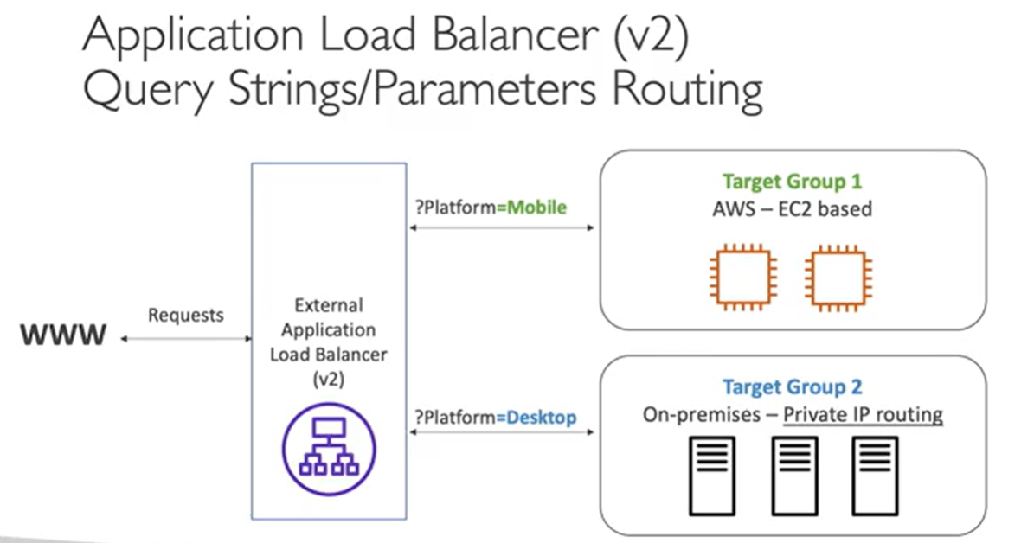

*Summary:- to enable ALB you need to create target group first where you will group all EC2 instance*

*And you attach that TG to ALB you are creating this will balance ,but if you need extra security then*

*Go to EC2 security Group and there edit it and allow only traffic from ALB by attaching security group in*

*Inbound*

# RDS

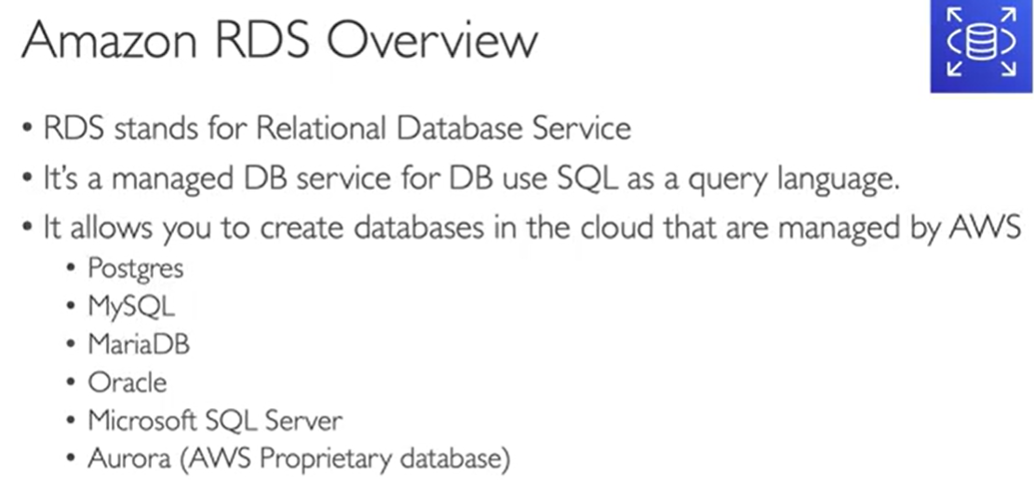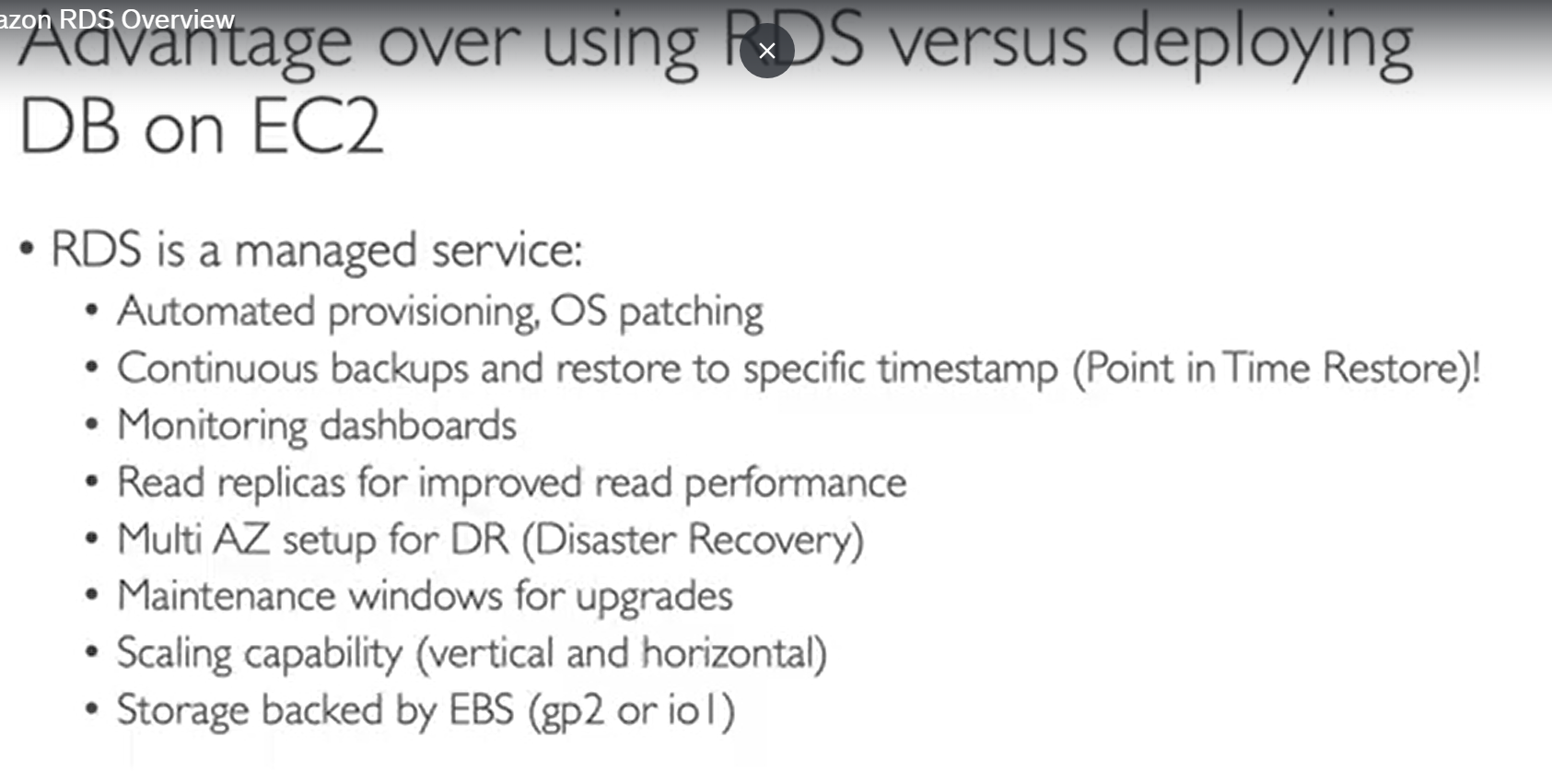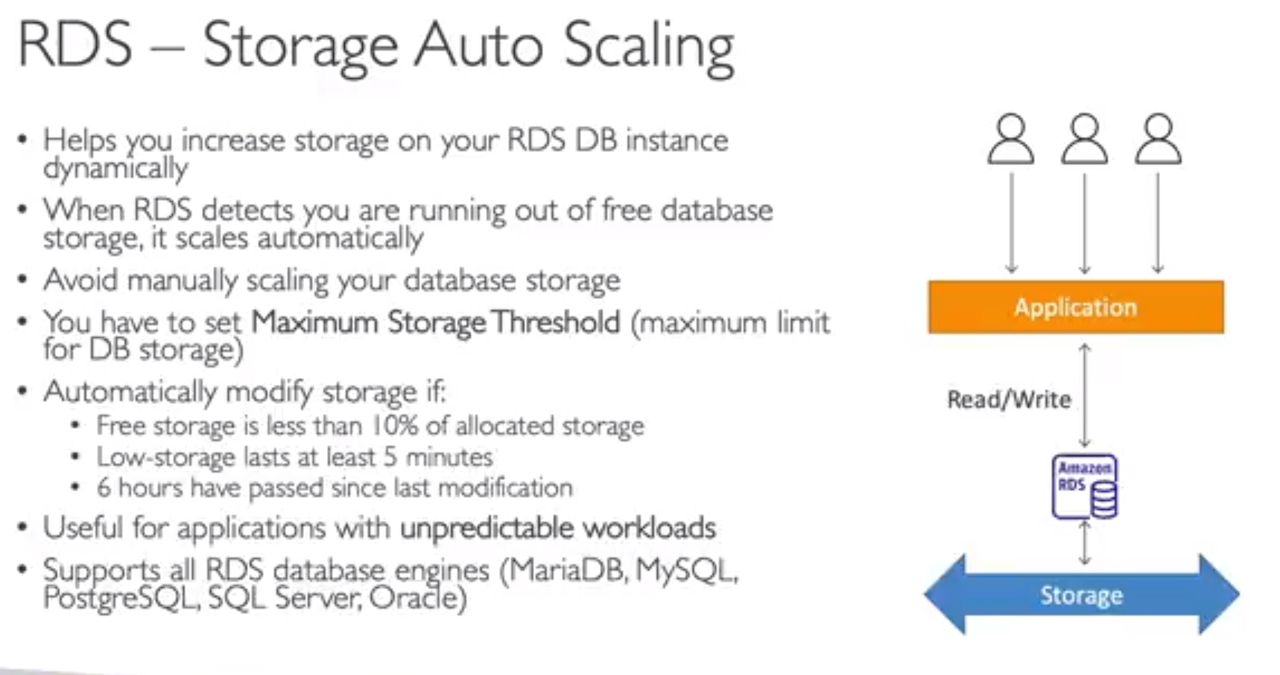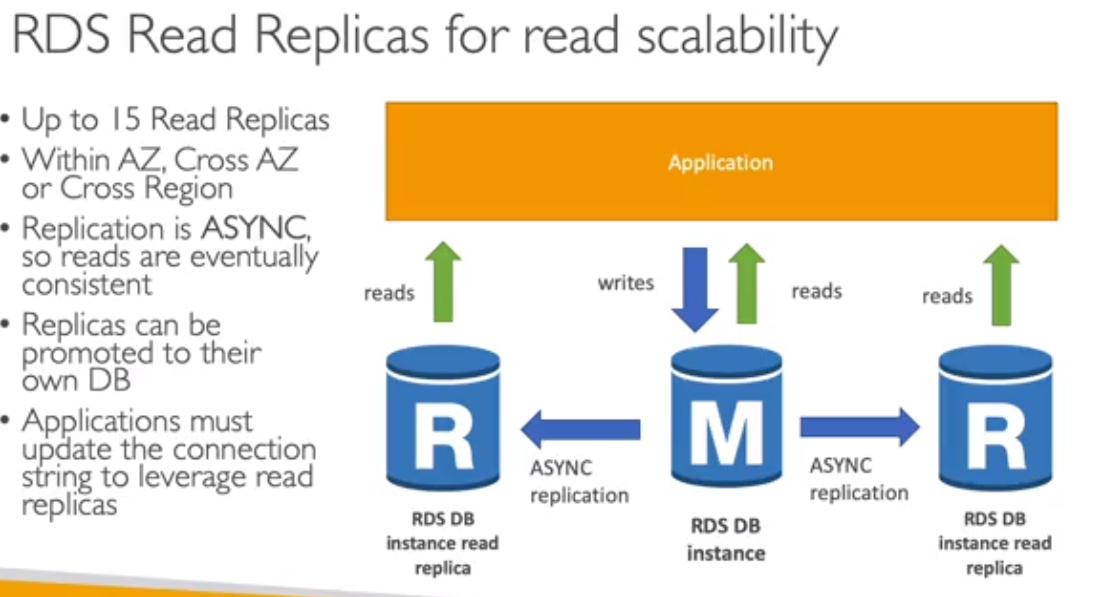

# DNS & Route 53

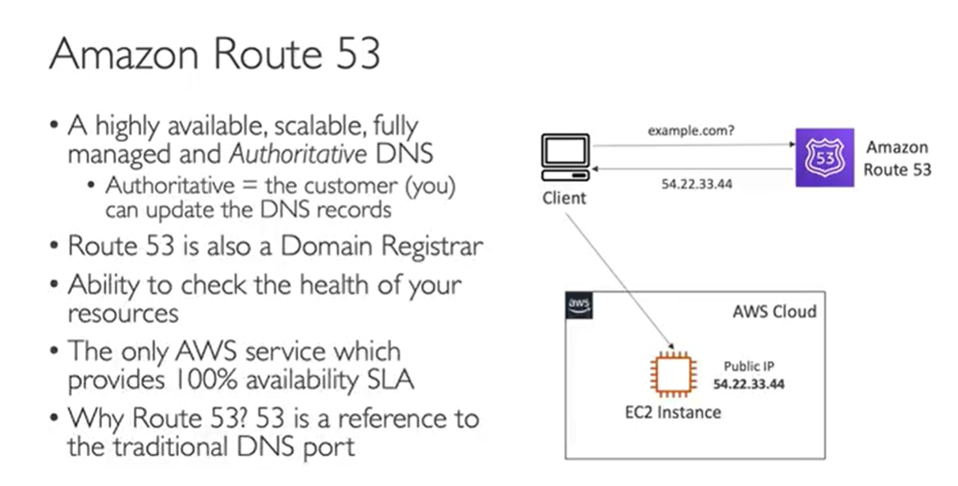

# VPC

VPC PATH:-

- **1) VPC creation**

* Enter Name
* CIDR as per above limit eg. 10.0.0.0/16 (This is to define subnet range)
* tenancy (if EC2 will have dedicated hardware or not )

**2) SUBNET creation - create 2 for private and 2 for public**

* Select VPC first
* Add Name ,AZ,
* Add IPV4 CIDR block eg 10.0.0.0/24
* for Public enable auto assign public IP
* FOR public will launch a EC2 instanse to enable internet connectiovity thorugh IGW so normal Ec2 launch just in network setting select VPC you have created above Then select public subnet after VPC selection.

**3)Internate Gateway Creation (IGW)**

* Name and hit create
* Attach it to VPC you have created
* Edit route table to do that created below

**4)Route Table creation**

* Two one for private and one for public :- name ,VPC and hit create
* Now for public route table attach public subets
* For private attach private sunbets
* Now Edit public route table to send traffic to IGW (by default local was enable add more for IGW)

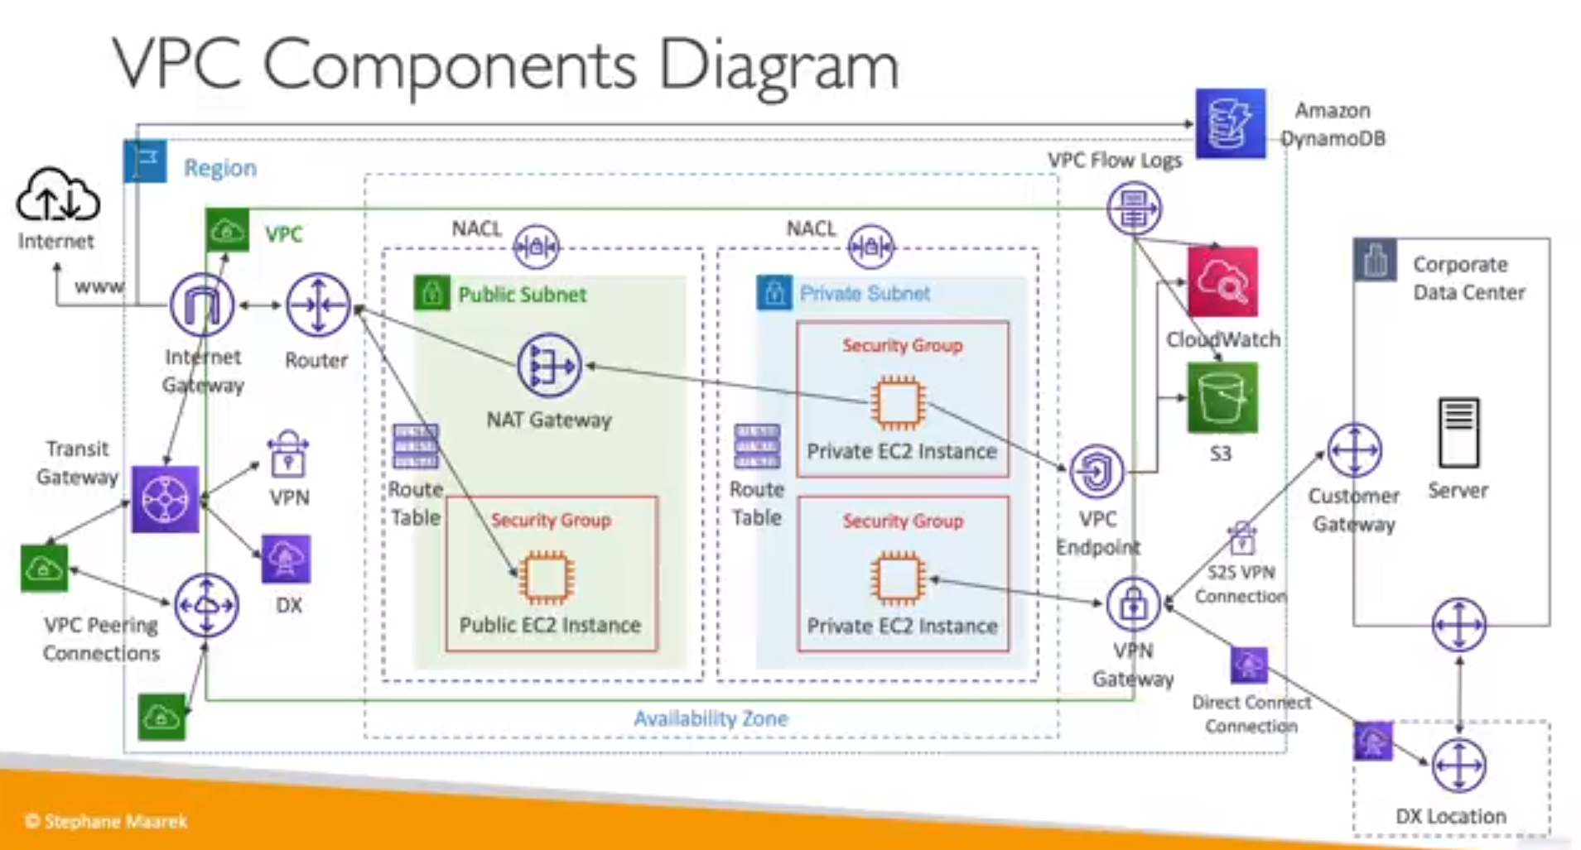

## CIDR

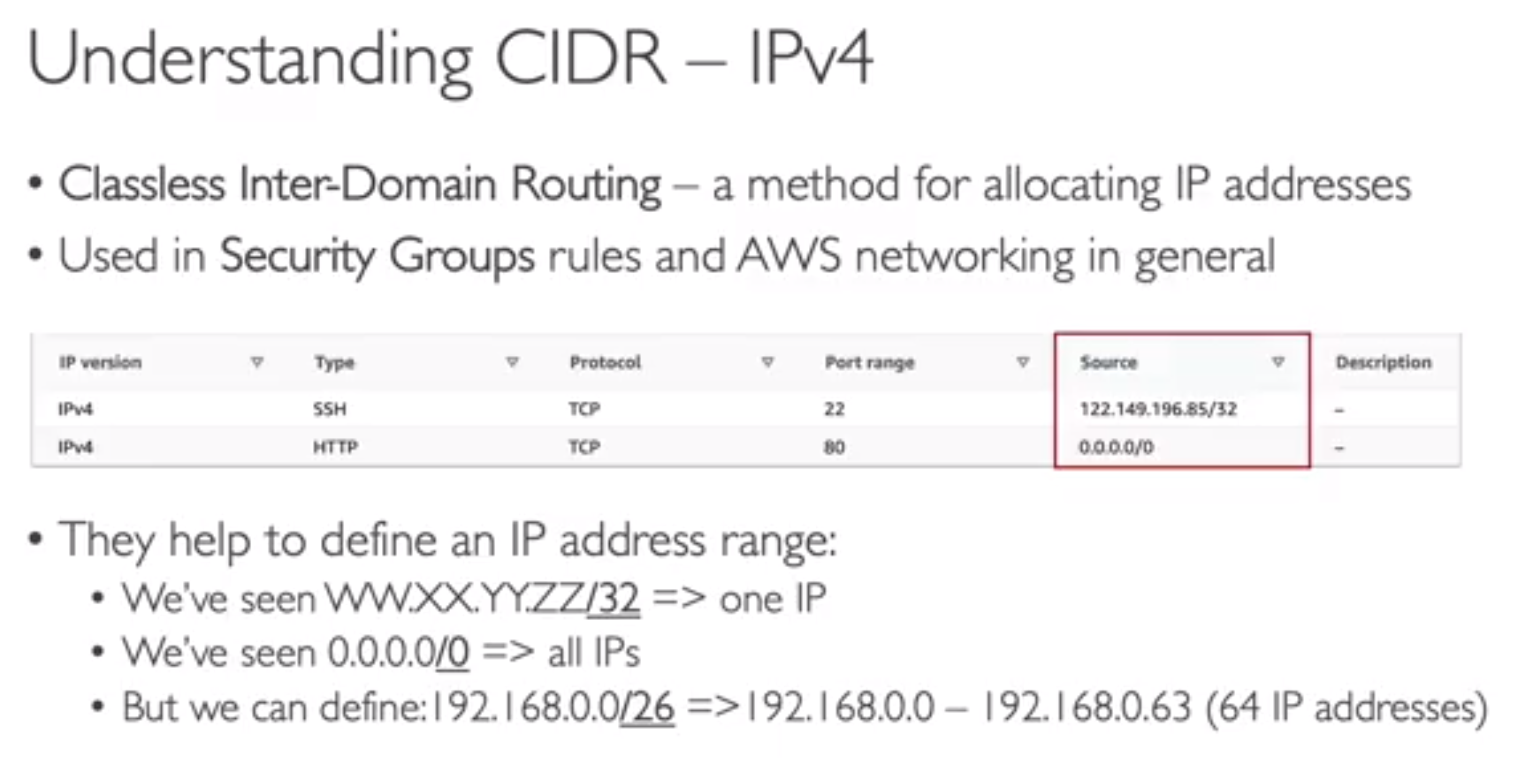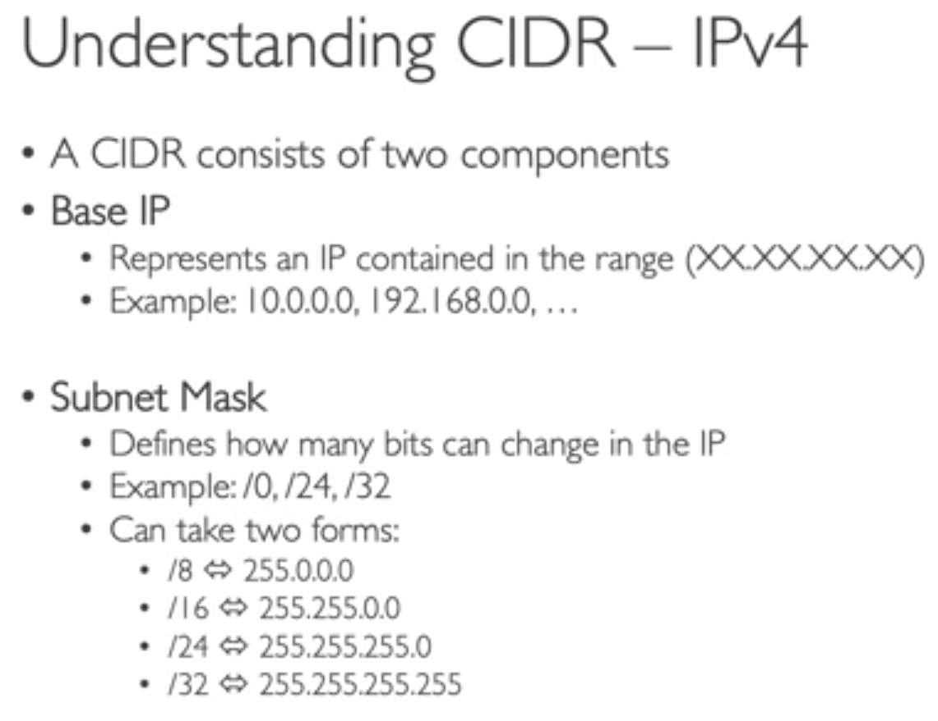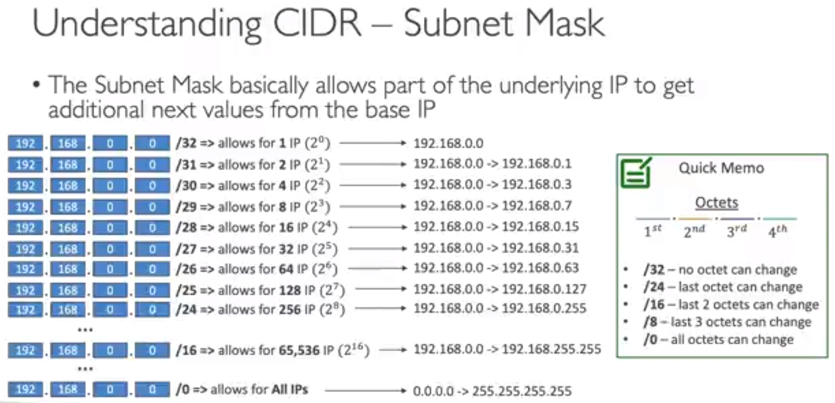

## Public VS private IP

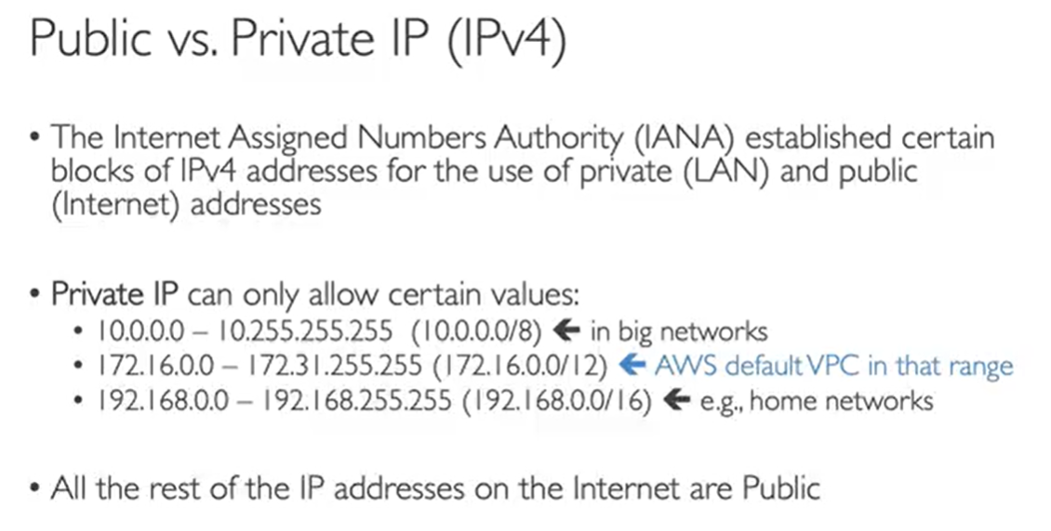

Public subnet – The subnet has a direct route to an internet gateway. Resources in a public subnet can access the public internet. Private subnet – The subnet does not have a direct route to an internet gateway. Resources in a private subnet require a NAT device to access the public internet.(So main difference is in route tables)

## Default VPC

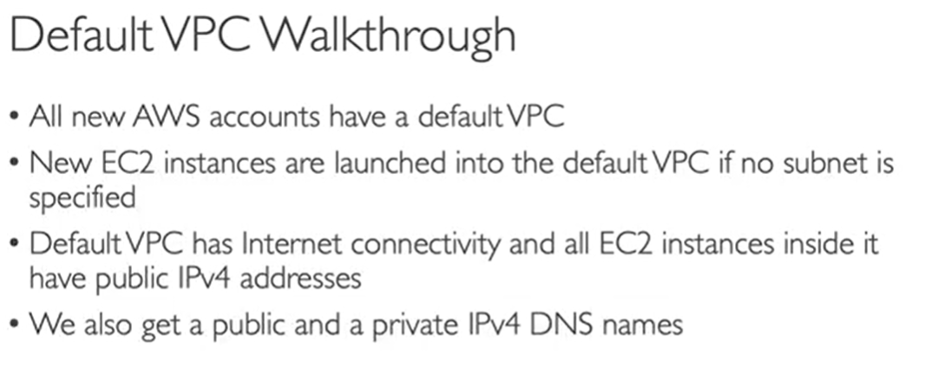

*Subnets are linked to VPC Each subnet has a route table and network ACL*

*Route table will help your traffic being routed your VPC*

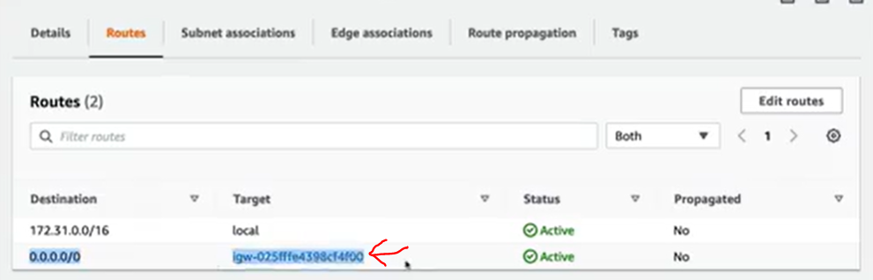

This means All traffic will go to this internet gateway ,this gateway is attached to my VPC ,hence internet t connectivity was enabled for my EC2.

VPC

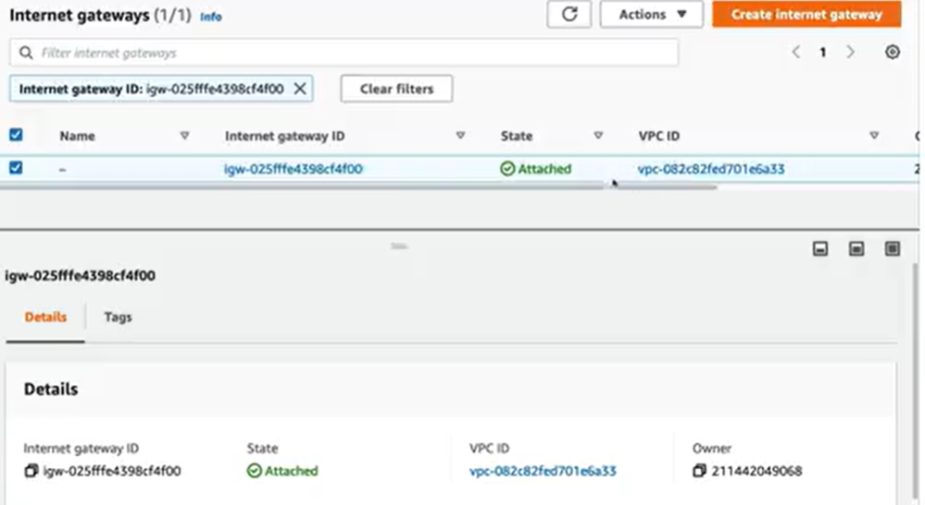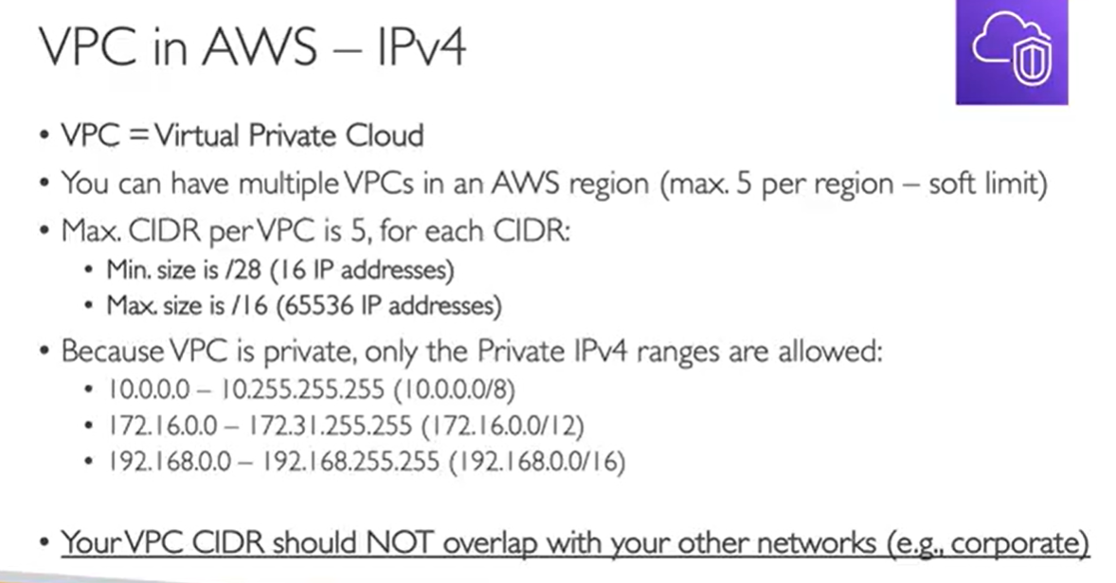

*Steps to create VPC 1) Enter Name ,2) CIDR as per above limit eg. 10.0.0.0/16 3) tenancy (if EC2 will have dedicated hardware or not )*

## Add Subnet into VPC (above created)

A subnet is subrange of ipv4 address in your VPC

You Declare a range In VPC of CIDR inside that you create different subnets

Private and public which will increase more security for private subset is for

Resources that need extra security

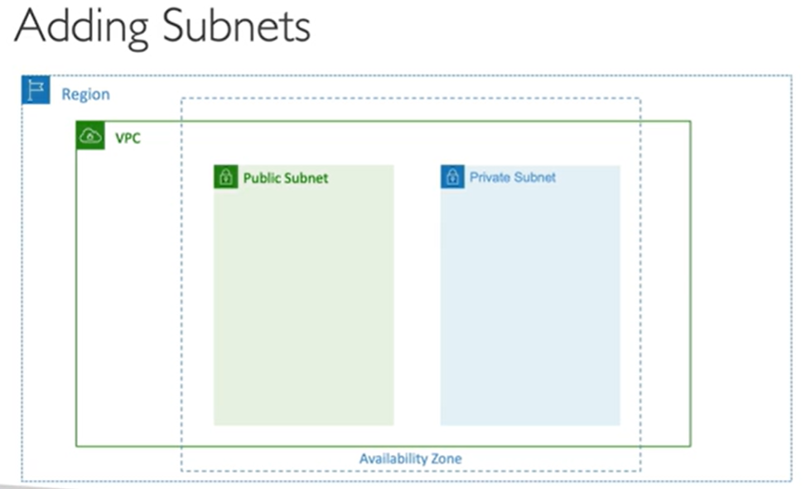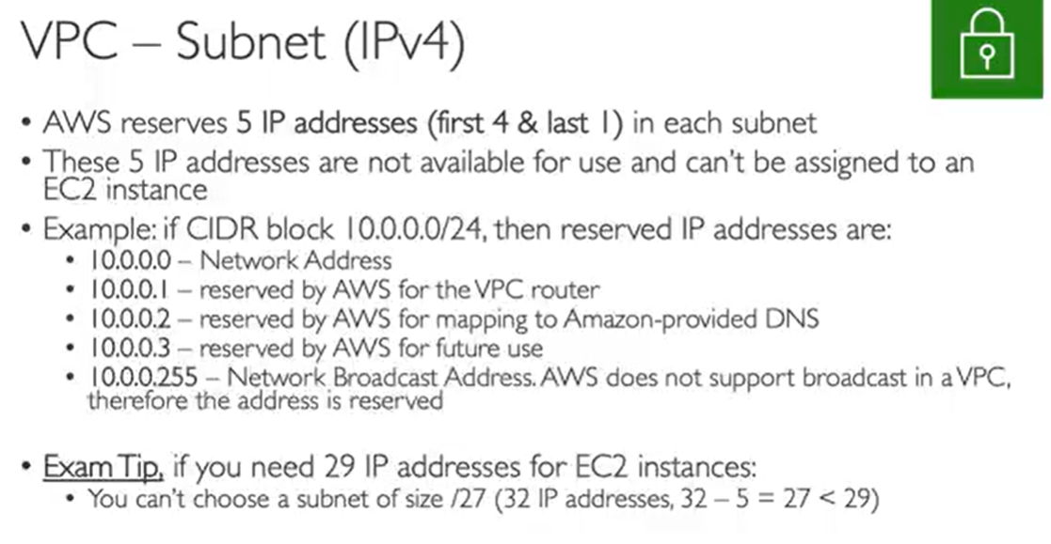

Steps to Create Subnets:-1) Select VPC first 2) Add Name ,AZ, 3) Add IPV4 CIDR block eg 10.0.0.0/24

Such that create 2 for private and 2 for public with next ranges ,currently both is not having net access

So will discuss below 4) for Public enable **auto assign public IP**

### Internet Gate for subnets:-

Basically which subnet is private and which is public

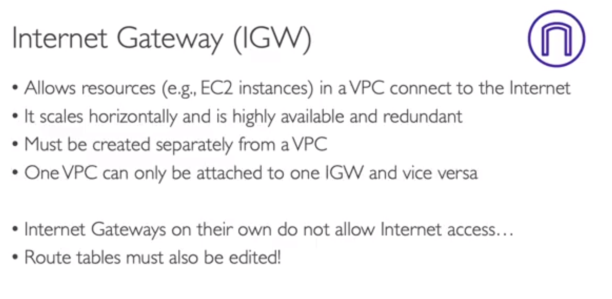

***SUMMARY SO FAR :- First We need to create VPC***

***Then we will create subnets for it***

***Then for the we will create internet gateway (IGW) (VPC - IGW is one to one mapped)***

***For IGW we need to edit Route Table to enable it.to Edit it we need to create a public EC2 in***

***Our public subnet and then we edit our Route Table .so that Ec2 can connect to router which connect to IGW and then to internet as shown below***

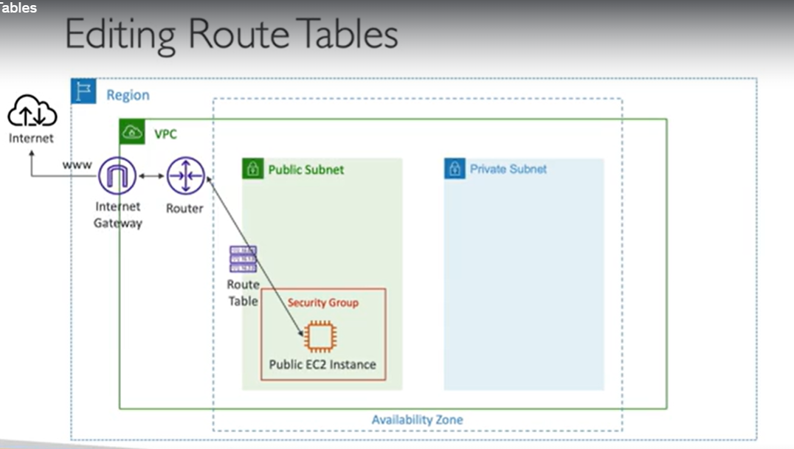

So for This Ec2 launch go to normal launch and in network setting select VPC you have created

Then select subnet after VPC selection.

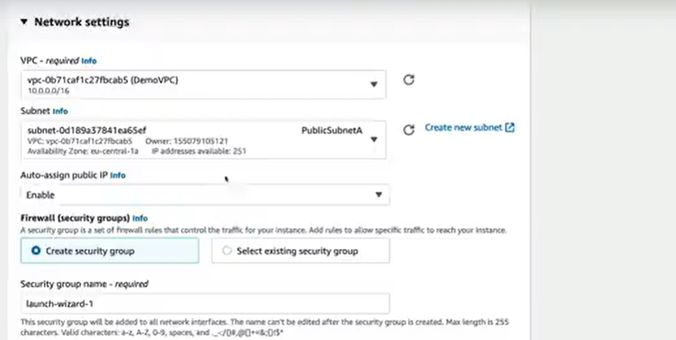

***So by this Ec2 Router connection we will decide which subnet is public ,so far it was just name***

***Now we will create IGW:- 1) Name and hit create***

***2)Attach it to VPC***

1. ***Still we need to edit Route Table***

***So create Two one for private and one for public :- name ,VPC and hit create***

1. ***Now for Public route Table attach public subnets***

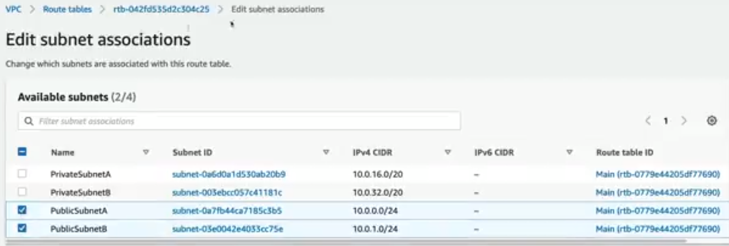

1. And same associate private subnets with private Route table
2. Now we will edit public route table (as our EC2 is running with public subnet and that is associted with public route table)

Route right now Any IP with CIDR will route to local but we will edit it

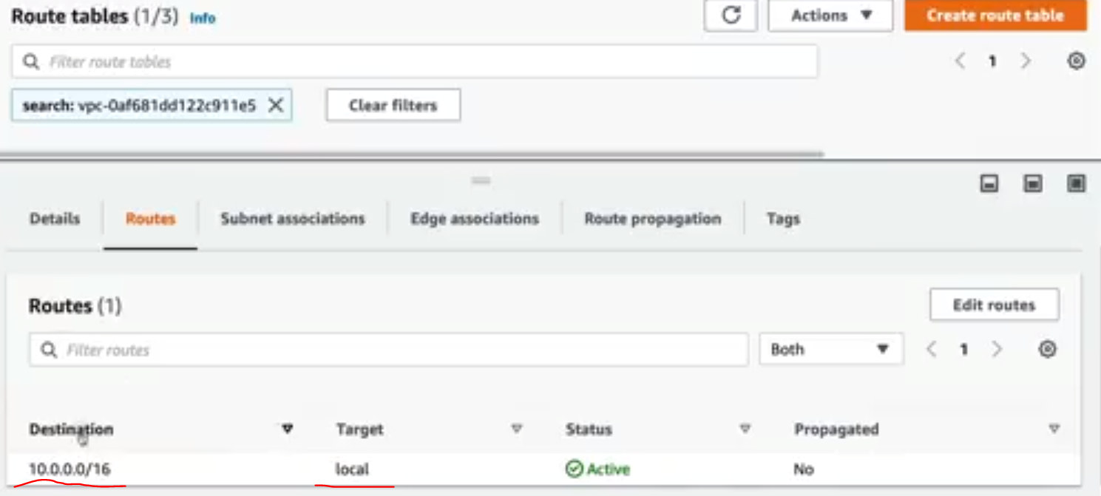

***Any ip except above will hit IGW***

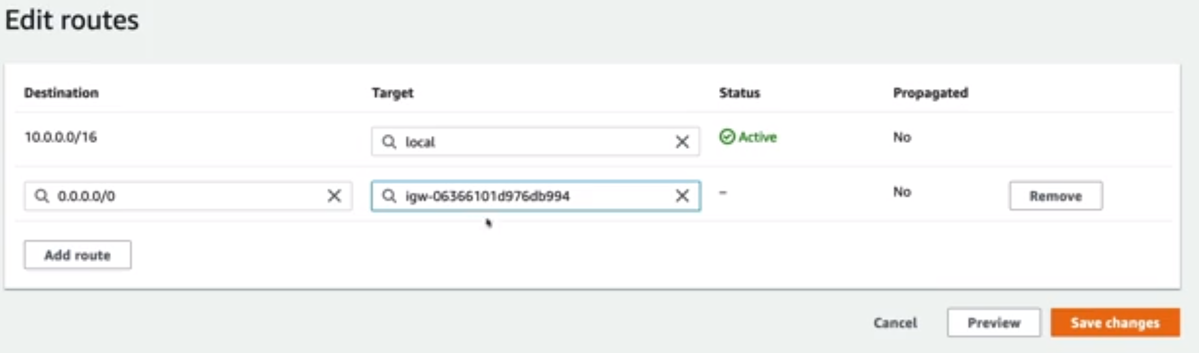

So this means if its local Ip route it to local first and then if anything else route it to Internet

## BastionHost

Out user wants to access an ec2(via ssh) in private subnet but users are in public ,It’s a normal Ec2 in public subnet with these rules

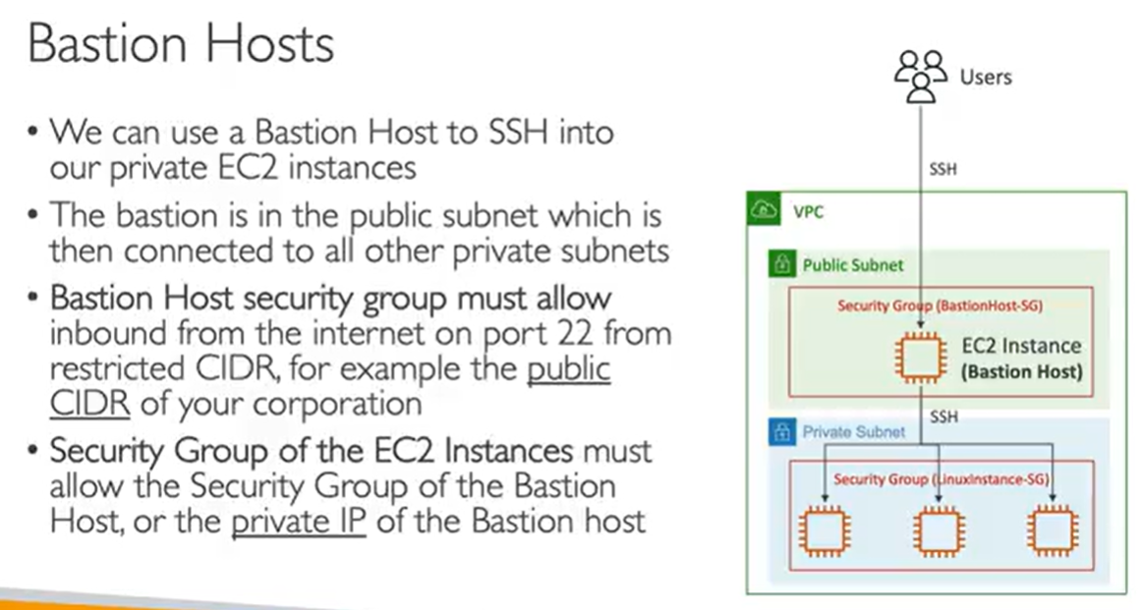

Example :- In Public Subnet you have EC2 name bastionHost create other in Private name Demo VPC

For that create a SG

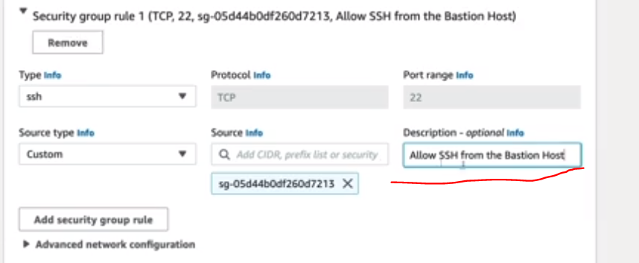

Basically you need to add public (bastionHost) SG while creating private Ec2 instance and you will be able to access

## NAT Gateway:-

Network address translation If we want to connect private instance to internet

So we will create nAt gateway in public subnet and access it in private

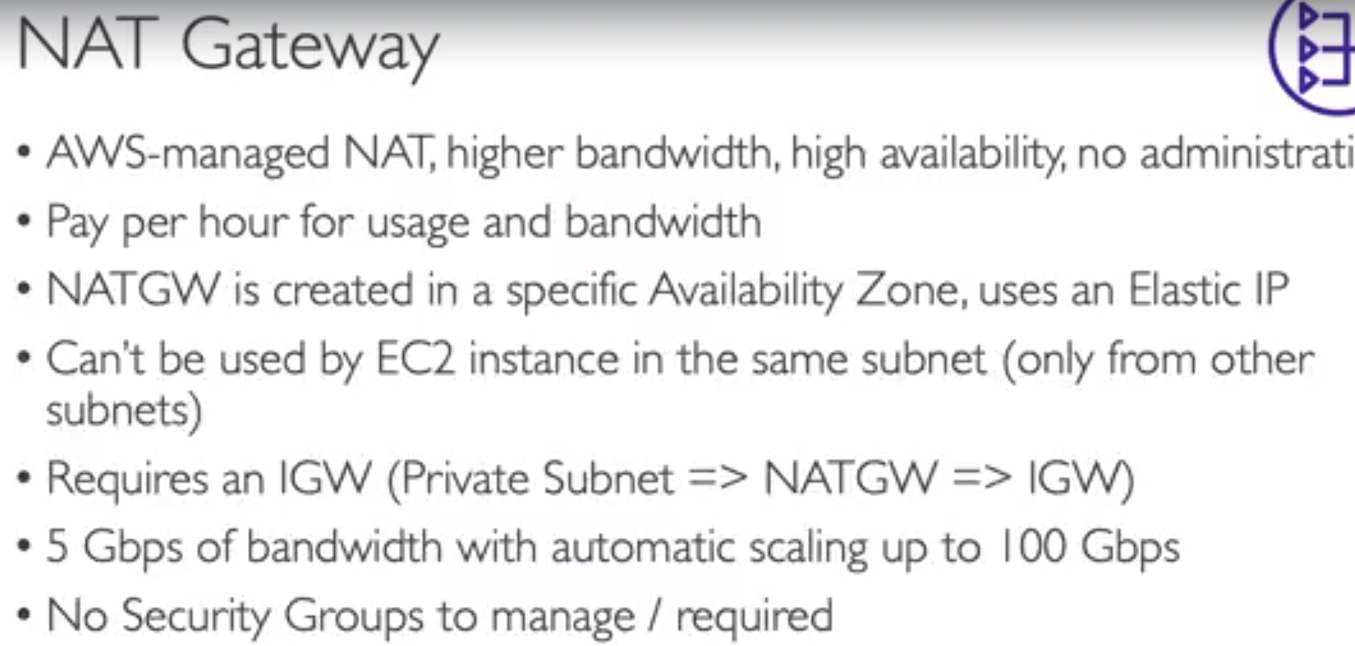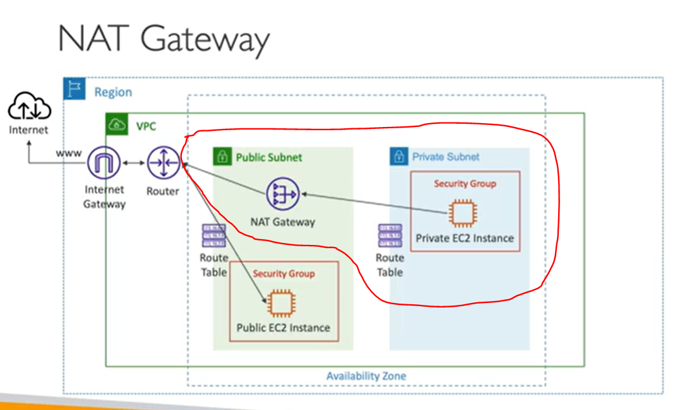

Steps:- Name ,add public subnet ,conenctivity is public ,allocate Elastic Ip ,create

Now we edit private Route table

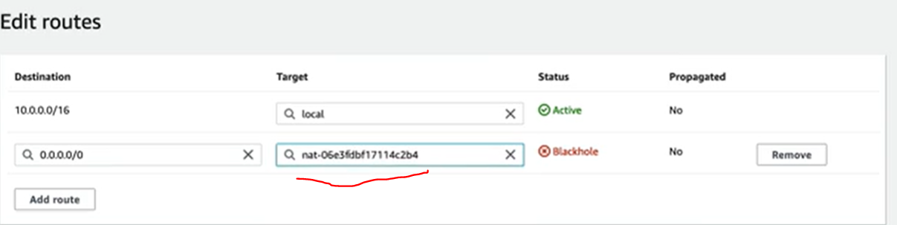

## NACL & security Group

Nacl provide one level extra security before SG,NACL is stateless while SG is stateful

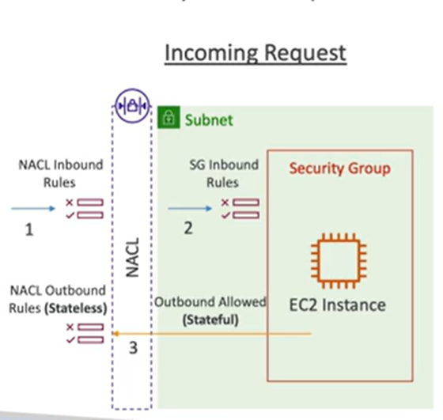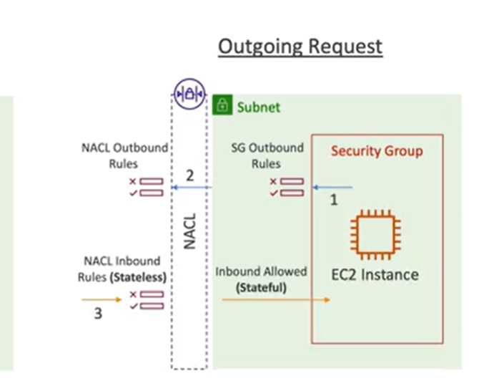

Besically in case in incomming req SG & NACL inbount is eval but in case of statefull SG as same req from EC2 to requester it will not eval outbound rules as it has a state ,but NACL always eval both

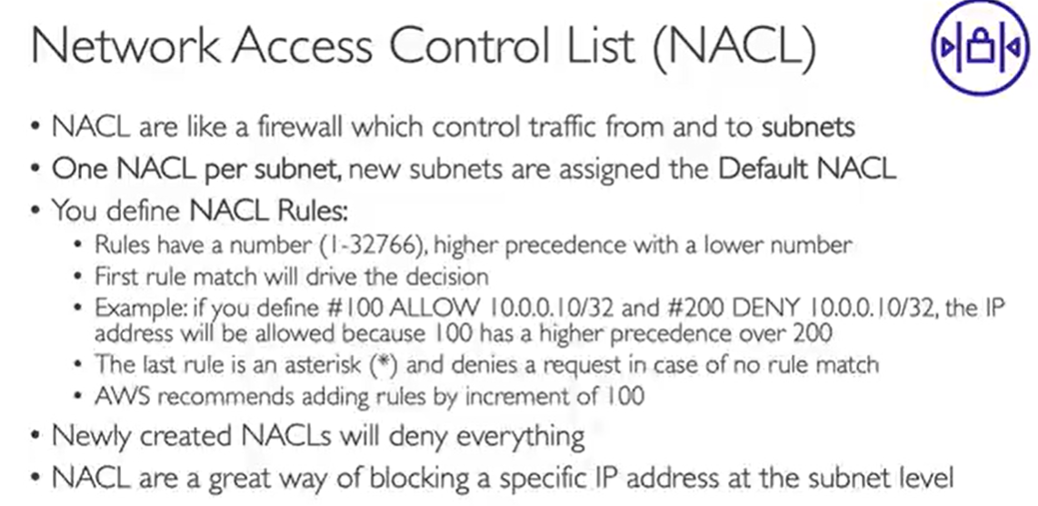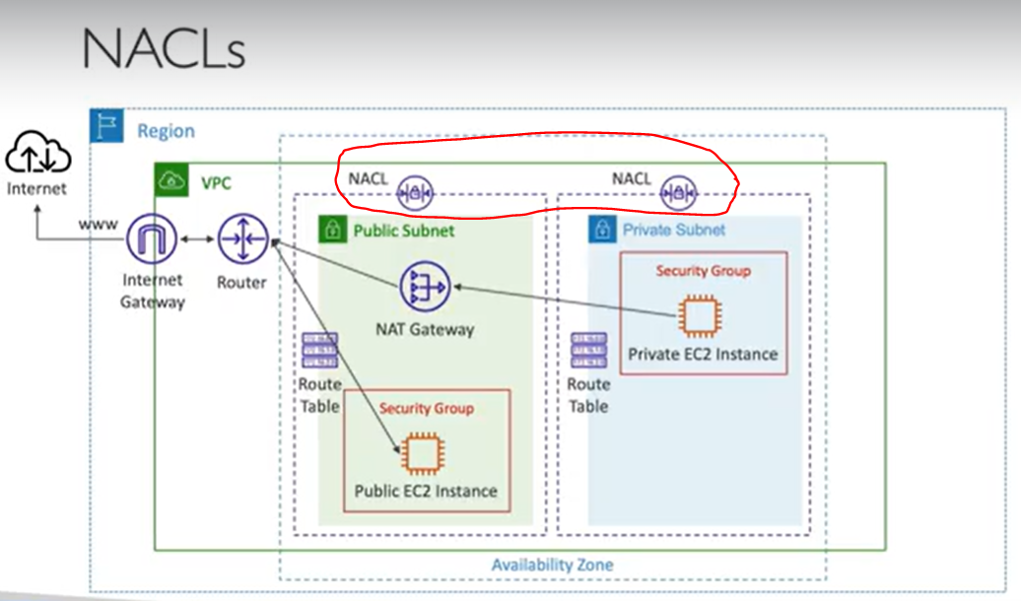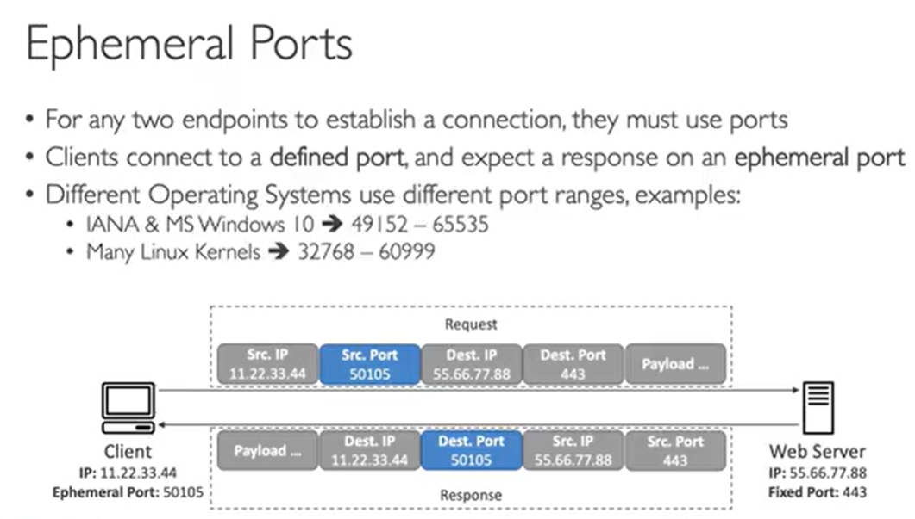

Basically client also open a port to receive reponse from server

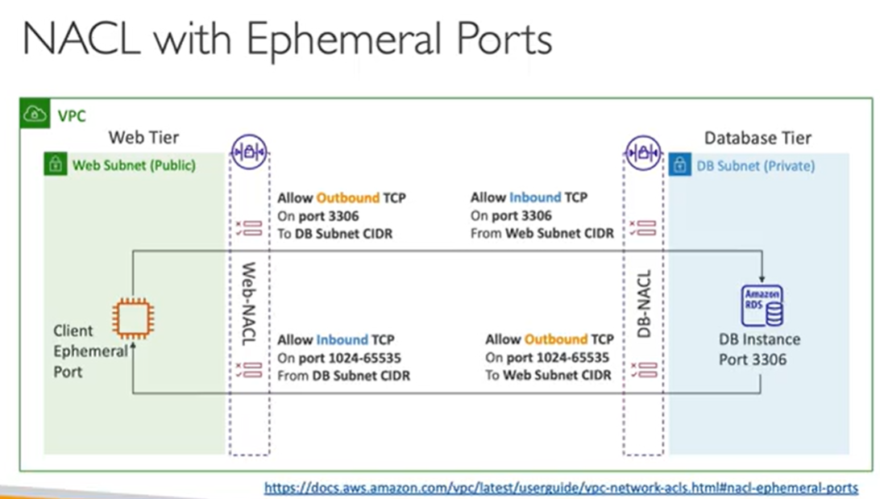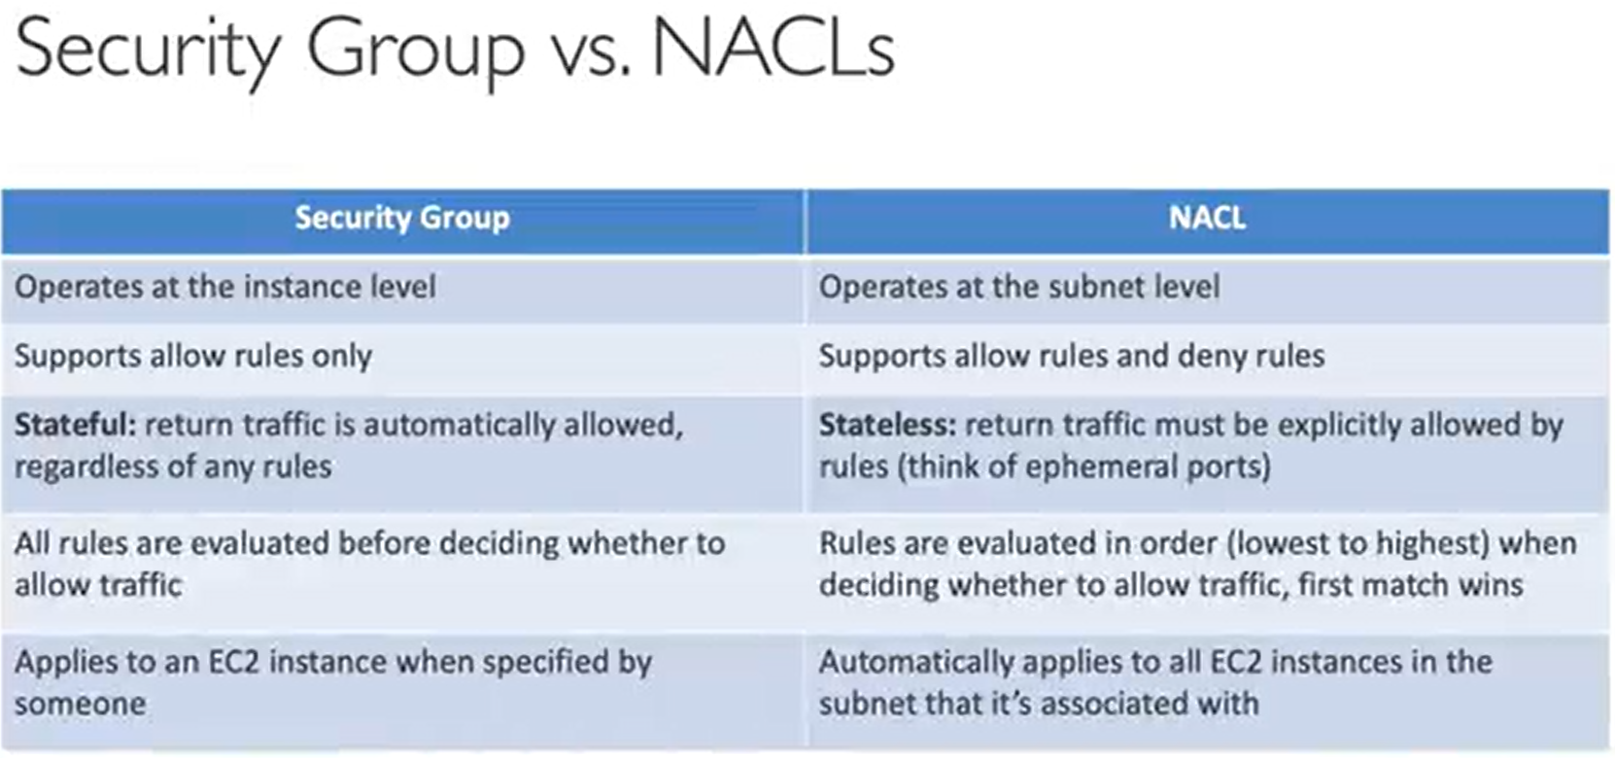

## VPC peering (pcx)

If we need to connect Two VPC over AWS network

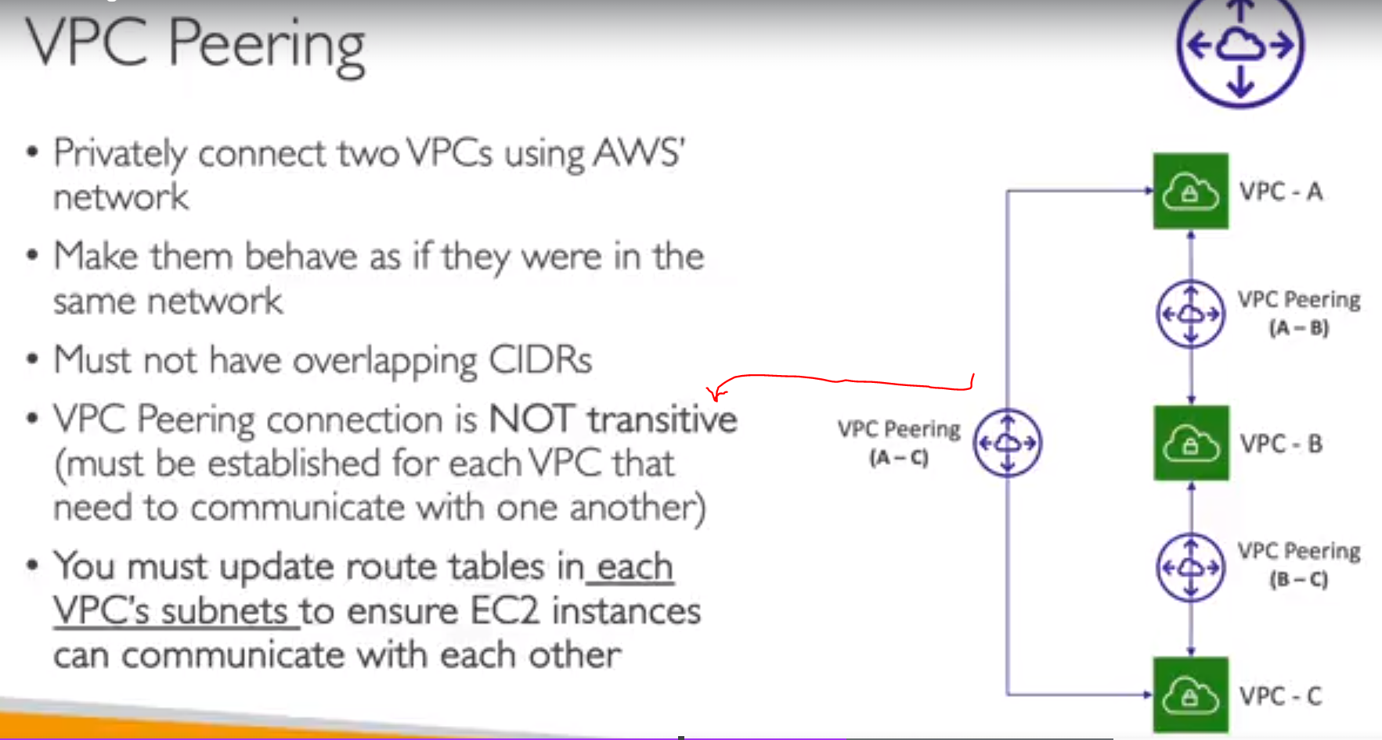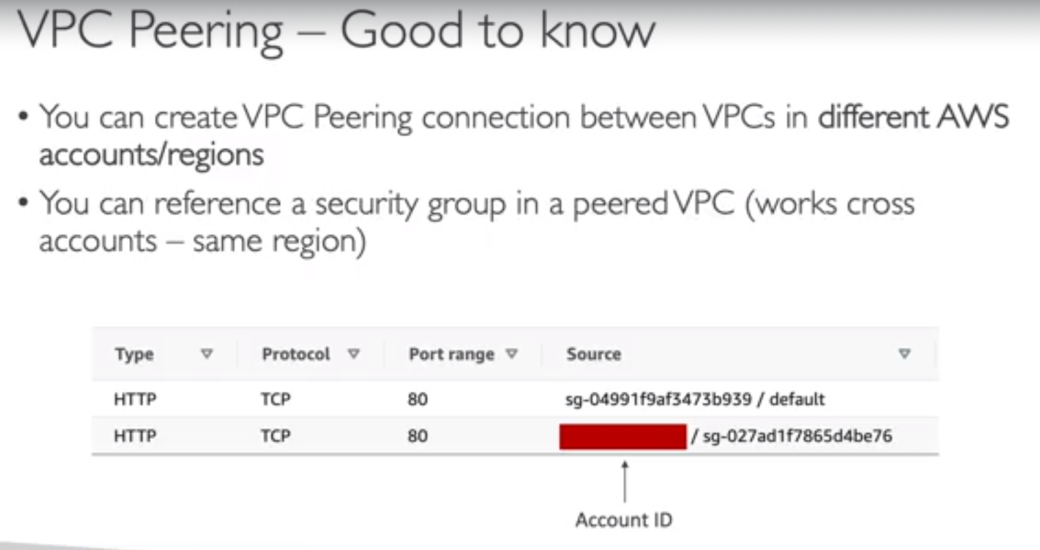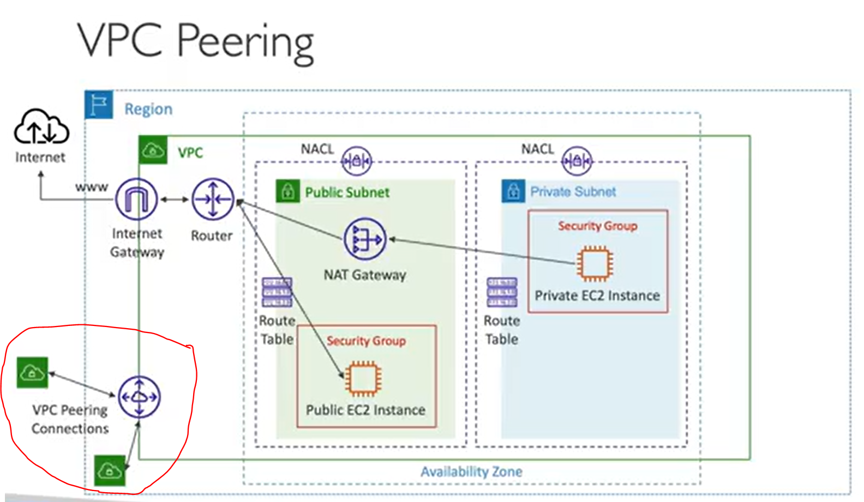

Steps to peer Two VPC eg , DEMO_VPC and DEFAULT_VPC

Test connection before its not connecting 172 is private subnet Ec2(Default_VPC) and 10. Is public Ec2

In DEMO_VPC

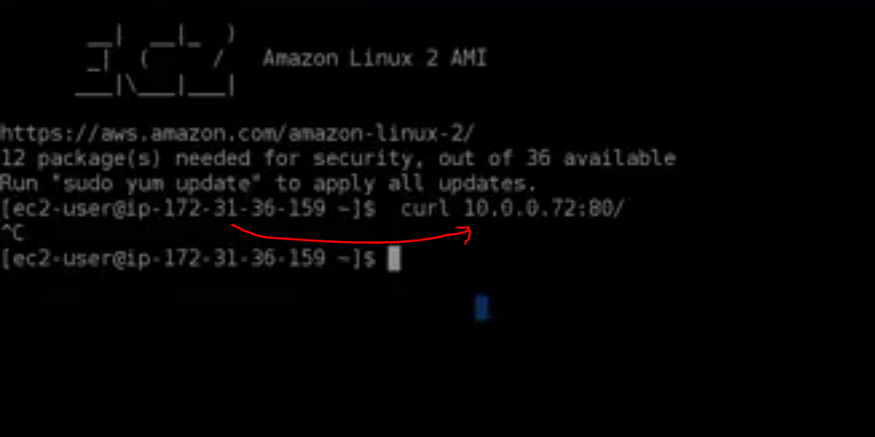

1. Create Peering Connection
   1. Name DEMO_peering
   2. Requester is DEMO_VPC
   3. Accepter will be DEFAULT_VPC
   4. Create
2. Still we need to modify Route table

Go to public route table and edit route we need to provide CIDR that is inline with Default VPC

So check that in Default VPC

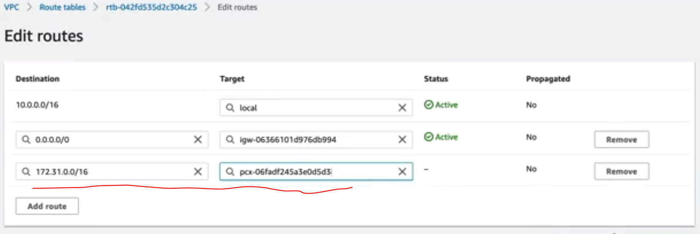

Now we created a route from Demo to Default but we need to modify other route table also

So now Default Route table

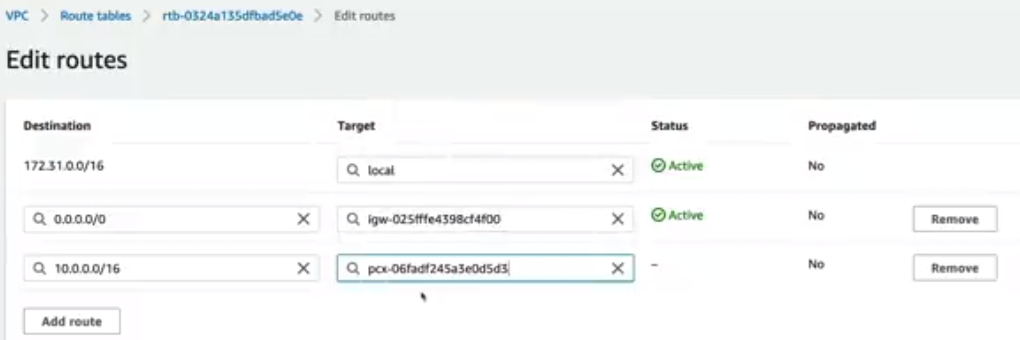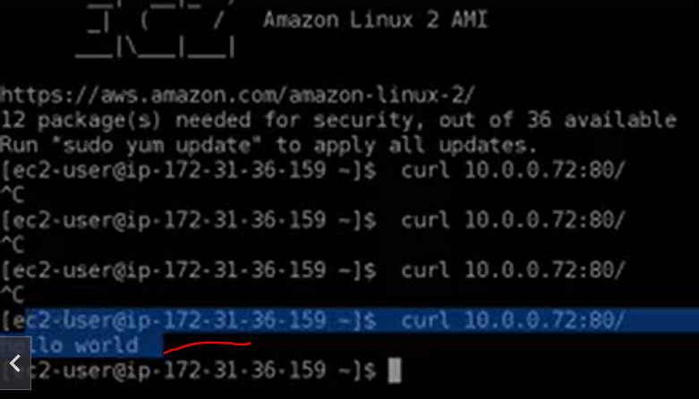

## VPC EndPoint

Service in Aws are accessible publically (example Dinamo DB) ,so your whole infrastructure access dinamo DB using IGW ,and all this traffic goes to public network ,and you have other services like s3

And you want to access those without going on public network (privaty) ,so for this we use VPC endpoint

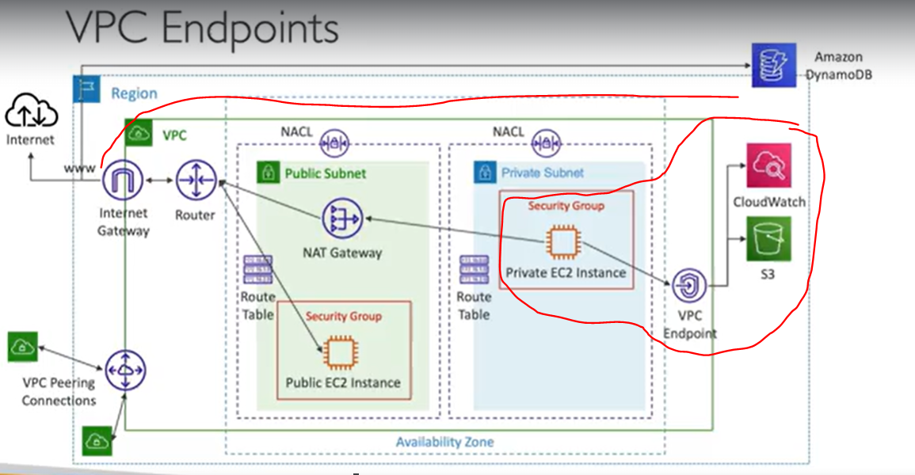

Now before Endpoint if private EC2 want to access Amazone SNS it goes to NAT and then to IGW and then access and for Public Ec2 via IGW this is fine but its costly so instead of this we can use VPC Endpoint (Deployed within your VPC) so we can make private subnet go though VPC endpoint into directly to SNS and network has never left AWS

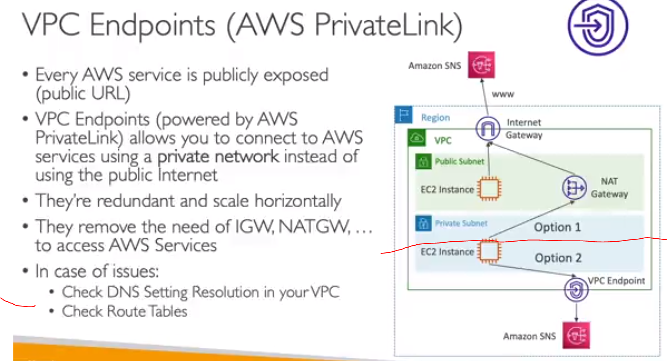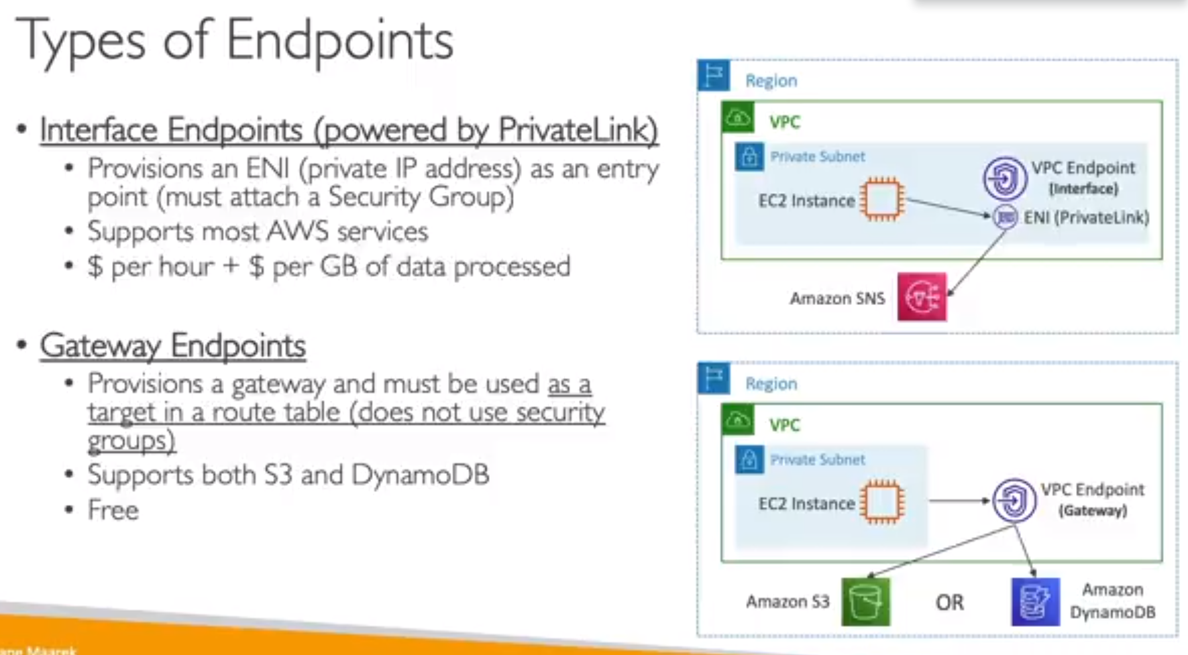

Steps To create VPC endpoint

1. Name ,Aws service (for s3), select interface type Endpoint ,select VPC In which this endpoint will be deployed
2. Ensure DNS Name is enabled
3. AZs Subnets(In which AZ and subnet ) ,Select SG

Other option is to select Gateway Endpoint

Update Route Table (of private as we want to connect this to s3)

Any request made within my private subnet in this route table will be routed to this EndPoint

Now we can access via bastion host > private Ec2 and then to s3 via Endpoints

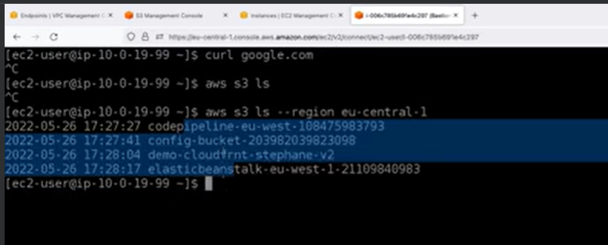

## VPC Flow logs :-

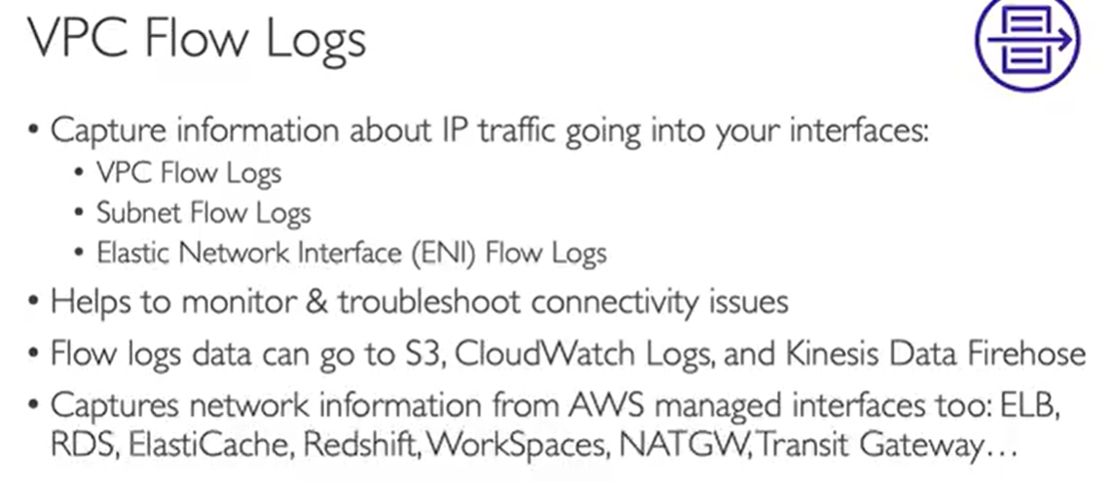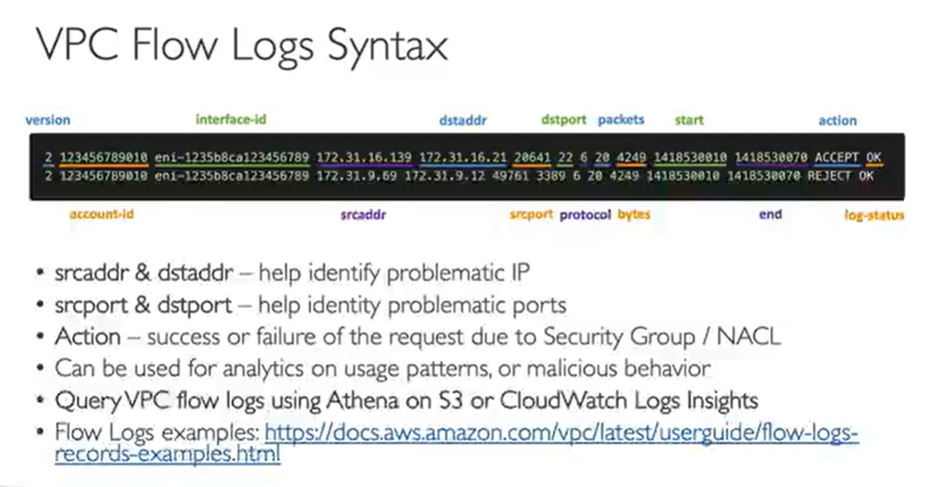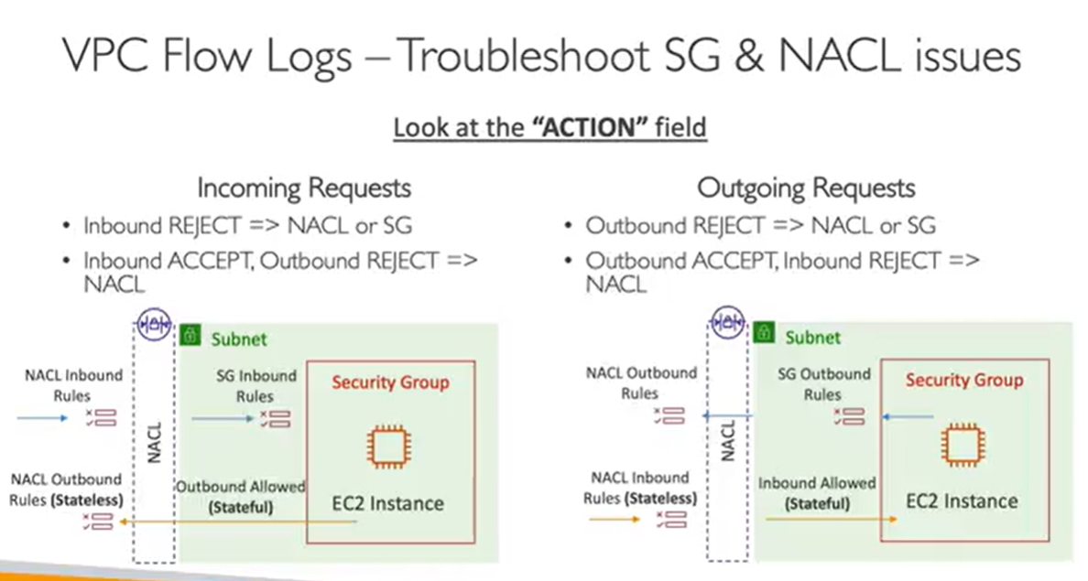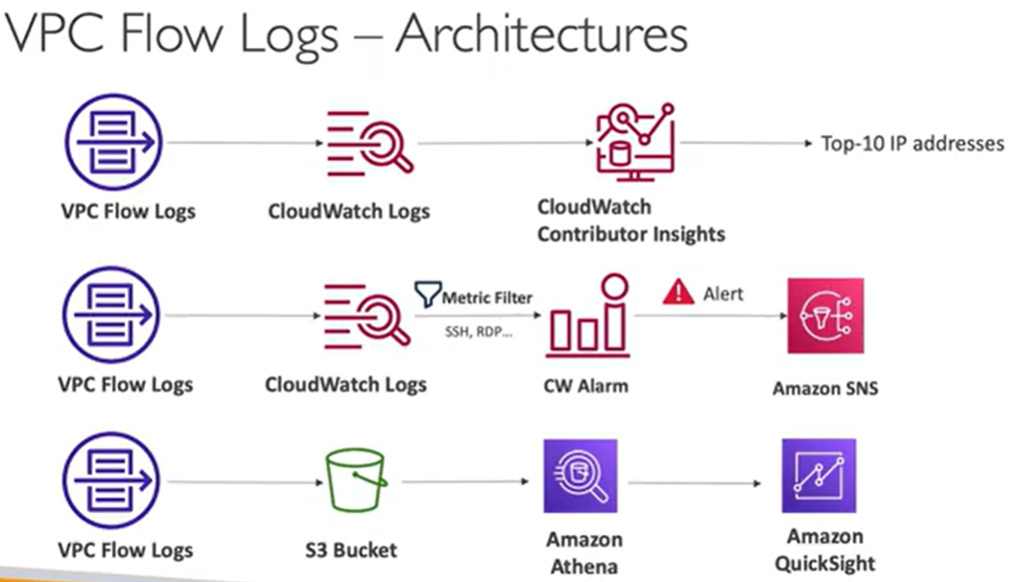

# SERVERLESS